**Data Analysis with Python**

**1.Concept Overview-Python**

1.1**.Variable:**

Container to store values

**Code:**

A=5

1.2**.Print:**

It is a function which used to display

**Code:**

a=5

print("I am",a,"years old")

**Output:**

I am 5 years old

**1.3.Operators:**

operators are special symbols, combinations of symbols, or keywords that are used to perform operations between operands.

**Arithmetic operators:** Arithmetic Operators are used to perform mathematical operations like addition, subtraction, multiplication, and division

**Code:**

a=5

b=25

print(a+b)

print(a-b)

print(a*b)

**Output:**

**30**

**-20**

**125**

**Relational operators:**Relational operators in python are used to compare the operand values on either side**.** The relational operators in Python return a boolean value i.e., either True or False, based on the value of operands.

**Code:**

a=7

b=7

print(a==b)

print(a>b)

print(a!=b)

print(a<b)

print(a>=b)

print(a<=b)

**Output:**

True

False

False

False

True

True

**Logical operators:**Logical Operators in Python are used to perform logical operations on the values of variables. The value is either true or false.

**Code:**

a=9

b=25

print((a>b)and(a<b))

print((a>b)or(a<b))

**Output:**

False

True

**Membership operators:**Membership operators are operators used to validate the membership of a value. The 'in' operator is used to check if a value exists in a sequence or not.

**Code:**

a="army"

print("x" in a)

**Output:**

False

**1.4.Control flow-Conditional statements**

**Simple if:**

**Code:**

#condition-if

#write a program to get a number from the user and check whether it is positive or negative

a=int(input("enter a number:"))

if(a>0):

print(a, "is positive")

**Output:**

enter a number:7

7 is positive

**If else:**

**Code:**

**a=int(input("enter number:"))**

**if a==0:**

**print(a, "is nuetral")**

**elif a>0:**

**print(a, "is positive")**

**else:**

**print(a, "is negative")**

**Output:**

enter number:-4

-4 is negative

**1.5.Control flow-Looping statements**

**For loop:**A for loop in Python is a control flow statement that is used to repeatedly execute a group of statements as long as the condition is satisfied.

**Code:**

n=6

for i in range(1,11,1):

a=n*i

print(a)

**Result:**

6

12

18

24

30

36

42

48

54

60

**While loop:**A while loop is a control flow statement which repeatedly executes a block of code until the condition is satisfied.

**Code:**

n=int(input("enter a number:"))

i=1

while(i<=n):

i=i+1

print(i)

**Output:**

enter a number:7

2

3

4

5

6

7

8

**1.6.Data slicing**

Slicing is the extraction of a part of a string, list, or tuple. It enables users to access the specific range of elements by mentioning their indices.

**Syntax:**

list_name[ start:stop:step]

**Code:**

a="python is easy"

print(a[: :-1])

print(a[4:7:1])

**Output:**

ysae si nohtyp

on

**1.7.Type casting:**

Casting, also known as type conversion, is a process that converts a variable's data type into another data type. These conversions can be implicit (automatically interpreted) or explicit (using built-in functions)

**Code:**

a=5

b=12.25

print(a+b)#implicit

print(int(a+b))#explicit

**Output:**

17.25

17

**1.8.Collections-list**

* Collection of elements
* List is heterogenous
* List is mutable(modifiable)

**Code 1:**

l1=[74,"neha",22.79]

print(l1)

**Output 1:**

[74, 'neha', 22.79]

**Code 2:**

l2=[1,"hema",3.7]

l2.insert(2,"neha")

print(l2)

**Output 2:**

[1, 'hema', 'neha', 3.7]

**List comprehension:**

* iterates
* applies some function on every element
* conditions
* it ‘s output is always a list

**Code 1:**

l3=[i**2 for i in l2 if i>=3]

print(l3)

**Output 1:**

[16, 81, 256, 625]

**Code 2:**the salaries of 5 employees in a company is taken as a list.the tax is 10% if the salary is less than or equal to 50000 or it is 15%.create a new list with tax amounts

[67000,45000,89000,34000,50000]

#list_name=[(body of if) if(condition) else (body of else) iterate]

sal=[67000,45000,89000,34000,50000]

tax=[i*0.1 if i<=50000 else i*0.15 for i in sal]

print(tax)

**Output 2:**

[10050.0, 4500.0, 13350.0, 3400.0, 5000.0]

**1.9.library functions**

**Numpy:**

* Numpy is a Python library used for working with arrays.
* It also has functions for working in domain of linear algebra, fourier transform, and matrices.
* Numpy stands for Numerical Python.

**Code 1:**

#CREATING A 2D ARRAY

B=np.array([[1,2,3],[4,5,6]])

print(B)

**Output 1:**

**[[1 2 3]**

**[4 5 6]]**

**Code 2:**

#creating a 3d array-rows,columns,groups

C=np.array([[[1,2,3],[4,5,6]],[[7,8,9],[1,2,3]]])

print(C)

**Output 2:**

**[[[1 2 3]**

**[4 5 6]]**

**[[7 8 9]**

**[1 2 3]]]**

**Code:**

#CHECKING DIMENSIONS

print(A.ndim)

print(B.ndim)

Print(C.ndim)

**Output:**

1

2

3

**Ones:**

**code:**

D=np.ones((2,3,2))

print(D)

**Output:**

[[[1. 1.]

[1. 1.]

[1. 1.]]

[[1. 1.]

[1. 1.]

[1. 1.]]]

**Zeros:**

**Code:**

#zeros

F=np.zeros((3,2))#2D

print(F)

**Output:**

**[[0. 0.]**

**[0. 0.]**

**[0. 0.]]**

**Identity matrix:**An identity matrix is a square matrix in which all the elements of principal diagonals are one, and all other elements are zeros.

**Code:**

J=np.eye(4)

print(J)

**Output:**

[[1. 0. 0. 0.]

[0. 1. 0. 0.]

[0. 0. 1. 0.]

[0. 0. 0. 1.]]

**Functions:**

**arange :**The arrange() function in the Numpy library is very powerful for producing sequences of numbers with defined intervals. It requires three parameters: start, stop, and step.

**Code:**

H=np.arange(2,30,2)#start,stop,step

print(H)

**Output:**

[ 2 4 6 8 10 12 14 16 18 20 22 24 26 28]

**reshape:**The numpy. reshape() function allows us to reshape an array in Python. Reshaping basically means, changing the shape of an array.

**Code:**

L=np.arange(2,8).reshape(2,3)

print(L)

H=np.arange(4,10).reshape(2,3)

print(H)

**Output:**

[[2 3 4]

[5 6 7]]

[[4 5 6]

[7 8 9]]

**Sum function:**

**Code 1:**

n=np.sum(H+L)

print(n)

**Output 1:**

66

**Code 2:**

G=np.sum((H,L),axis=0)**#it sums column-wise**

**print(G)**

**Output 2:**

[[ 6 8 10]

[12 14 16]]

**Code 3:**

G=np.sum((H,L),axis=1)**#it sums row-wise**

print(G)

**Output 3:**

[[11 13 15]

[ 7 9 11]]

**Code 4:**

n=np.ones((4,2))

h=np.ones((4,2))

print(np.sum((n,h),axis=0))

print(np.sum((n,h),axis=1))

**Output 4:**

[[2. 2.]

[2. 2.]

[2. 2.]

[2. 2.]]

[[4. 4.]

[4. 4.]]

**Array joining:**

**hstack and vstack:**Numpy hstack and Numpy vstack are similar in that they both combine Numpy arrays together. The major difference is that np. hstack combines Numpy arrays horizontally and np. vstack combines arrays vertically.

**Code:**

a=np.array([1,2,3,4,5,6])

a.resize(2,3)

print(a)

b=np.array([10,11,12,13,14,15])

b.resize(2,3)

print(b)

print(np.vstack((a,b)))#coloumns

print("\n")

print(np.hstack((a,b)))#rows

**Output:**

[[1 2 3]

[4 5 6]]

[[10 11 12]

[13 14 15]]

[[ 1 2 3]

[ 4 5 6]

[10 11 12]

[13 14 15]]

[[ 1 2 3 10 11 12]

[ 4 5 6 13 14 15]]

**dstack:**The dstack() function in numpy is used to stack or arrange the given arrays in a sequence depth wise (that is, along the third axis), thereby creating an array of at least 3-D .

* **groups becomes coloumns**
* **number of rows becomes number of groups**
* **coloumns becomes rows**

**Code:**

**a=np.arange(30).reshape(2,3,5)**

**print(a)**

**print("\n")**

**print(np.dstack(a))**

**Output:**

[[[ 0 1 2 3 4]

[ 5 6 7 8 9]

[10 11 12 13 14]]

[[15 16 17 18 19]

[20 21 22 23 24]

[25 26 27 28 29]]]

[[[ 0 15]

[ 1 16]

[ 2 17]

[ 3 18]

[ 4 19]]

[[ 5 20]

[ 6 21]

[ 7 22]

[ 8 23]

[ 9 24]]

[[10 25]

[11 26]

[12 27]

[13 28]

[14 29]]]

**random:** The random is a module present in the numpy library. This module contains the functions which are used for generating random numbers

**Code 1:**

A=np.random.rand(8,4)#rand range is between 0-1

print(A)

**Output:**

[[0.01633655 0.71324665 0.93775797 0.53335008]

[0.090491 0.03616235 0.32751192 0.85206397]

[0.75616349 0.53746053 0.08975027 0.81600267]

[0.17561724 0.16506891 0.41041712 0.653869 ]

[0.3557942 0.25469196 0.78588892 0.88262353]

[0.95583901 0.68431961 0.37648377 0.92097869]

[0.43827062 0.36740763 0.4411294 0.57316322]

[0.36463893 0.3453167 0.01030147 0.93866492**]]**

**Code 2:**

A=np.floor(10*np.random.rand(8,4))

print(A)

**Output:**

[[6. 8. 0. 3.]

[3. 2. 7. 3.]

[7. 1. 2. 6.]

[2. 8. 6. 9.]

[3. 2. 2. 3.]

[0. 4. 6. 3.]

[8. 2. 7. 7.]

[3. 4. 1. 6.]]

**vsplit and hsplit:**

* vsplit function is used to split an array into sub arrays vertically i.e row wise
* hsplit function is used to split an array into sub arrays horizantally i.e column wise

**Code 1:**np.vsplit(A,(3,5))#split it after 3rd row and 5th row

**Output:**

[array([[6., 8., 0., 3.],

[3., 2., 7., 3.],

[7., 1., 2., 6.]]),

array([[2., 8., 6., 9.],

[3., 2., 2., 3.]]),

array([[0., 4., 6., 3.],

[8., 2., 7., 7.],

[3., 4., 1., 6.]])]

**Code 2:**

np.hsplit(A,(1,4))

**Output:**

[array([[6.],

[3.],

[7.],

[2.],

[3.],

[0.],

[8.],

[3.]]),

array([[8., 0., 3.],

[2., 7., 3.],

[1., 2., 6.],

[8., 6., 9.],

[2., 2., 3.],

[4., 6., 3.],

[2., 7., 7.],

[4., 1., 6.]]),

array([], shape=(8, 0), dtype=float64)]

**Code:**

n=[np.pi/4,np.pi/3,np.pi/2,np.pi]

print(n)

**Output:**

[0.7853981633974483, 1.0471975511965976,1.5707963267948966, 3.141592653589793]

**Code 2:**

np.rad2deg(n)#converts radians to degrees

**Output:**

array([ 45., 60., 90., 180.])

**Code 3:**

b=([ 45., 60., 90., 180.])#converts degrees to radians

np.deg2rad(b)

**Output:**

array([0.78539816, 1.04719755, 1.57079633, 3.14159265])

**Statistics:**

**Mean:**

**mean = (sum of observations) ÷ (total number of observations).**

**Code:**

st=np.array([11,22,33,44,55])

np.mean(st)

**Output:**

33.0

**Median:**

If the given number of observations/data is odd, then the formula to calculate the median is: Median = {(n+1)/2}th term and if the observations is even, then the formula is given by: Median = [(n/2)th term + {(n/2)+1}th term]/2.

**Code:**

st=np.array([11,22,33,44,55])

np.median(st)

**Output:**

33.0

**Standard deviation:**

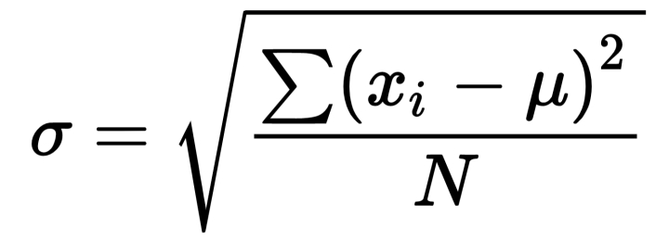

**Code:**

st=np.array([11,22,33,44,55])

np.std(st)

**Output:**

15.556349186104045

**Variance:**

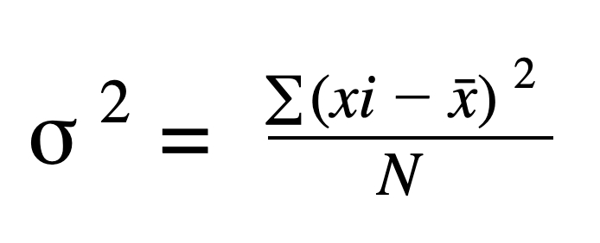

**Code:**

st=np.array([11,22,33,44,55])

np.var(st)

**Output:**

242.0

**Linear algebra:**

**Argument maximum number:**

Numpy argmax() in python is used to return the indices of max elements of the given array along with the specified axis. Using this function gets the indices of maximum elements of single dimensions and multi-dimensions(row-wise or column-wise) of the given array

**Code:**

c=np.arange(1,25).reshape(6,4)

print(np.argmax(c))#argmax will provide u the index of highest number in each row or coloumn in the given matrix

**Output:**23

**Code:**

d=10*np.random.rand(24).reshape(6,4)

print(d)

**Output:**

**[[4.07751998 8.72834794 8.97873355 5.95557456]**

**[6.58553538 2.38379297 9.23355193 9.42305738]**

**[8.50221714 3.01282204 2.4185026 2.45751048]**

**[6.46190302 9.19893241 4.35219561 3.28589104]**

**[9.8770008 4.53912116 5.75201058 4.9960637 ]**

**[0.1713341 3.35536689 2.15546352 3.97426257]]**

We use the function argmax() with the parameter axis that can be defined as follows:

● axis=0 , the index of the max element per column will be returned.

● axis=1 the index of the max element per row will be returned

**Code:**

print(np.argmax(d,axis=1))

**Output:**

**[2 3 0 1 0 3]**

**Code:**

print(np.argmax(d,axis=0))

**Output:**

**[4 3 1 1]**

**ARGUMENT MINIMUM NUMBER(argmin()):**

**● If axis = None , the array is flattened and the index of the flattened array is returned.**

**● If axis = 0, the index of the smallest element in each column is returned.**

**● If axis = 1, the index of the smallest element in each row is returned.**

**Code:**

print(np.argmin(d,axis=1))

**Output:**

**[0 1 2 3 1 0]**

**Code:**

print(np.argmin(d,axis=1))

**Output:**

**[5 1 5 2]**

**FLOOR:**

floor() function in NumPy is used to return the floor values of each element in an input array x such that for each of the elements of x , the floor values are less than or equal to it.

**Code:**

c=np.floor(10*np.random.rand(24)).reshape(6,4)

print(c)

**Output:**

**[[4. 8. 6. 3.]**

**[3. 8. 4. 7.]**

**[5. 0. 1. 8.]**

**[8. 3. 2. 0.]**

**[4. 1. 4. 2.]**

**[4. 7. 0. 9.]]**

**Inverse:**

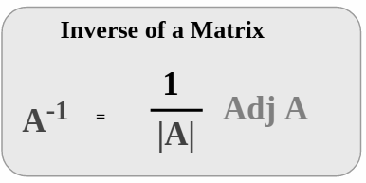

**Code:**

C=np.arange(1,5).reshape(2,2)

print(C)

np.linalg.inv(C)#linear algebra is sub-package of numpy

**Output:**

[[1 2]

[3 4]]

array([[-2. , 1. ],

[ 1.5, -0.5]])

**Code:**

C=np.arange(1,33,1).reshape(8,4)

print(C)

print(np.argmax(C,axis=1))

print(np.argmax(C,axis=0))

**Output:**

[[ 1 2 3 4]

[ 5 6 7 8]

[ 9 10 11 12]

[13 14 15 16]

[17 18 19 20]

[21 22 23 24]

[25 26 27 28]

[29 30 31 32]]

[3 3 3 3 3 3 3 3]

[7 7 7 7]

**Searching:**

**Code:**

H=np.array([11,45,22,79,14,8])

print(np.where(H%2==0))

**Output:**

(array([2, 4, 5]),)

**Code:**

z=np.array([4,7,8,9,10])

x=np.searchsorted(z,8)#gives the index of element to be searched

print(x)

**Output:**

2

**Sorting:**

**Code:**

X=np.array([[3,2,4],[5,1,0]])#sorting happens within row

print(np.sort(X))

**Output:**

[[2 3 4]

[0 1 5]]

**Iterating two arrays:**

**Code:**

names=np.array(["hema","neha","vyshu","divya","gopi"])

initials=np.array(["V","M","Y","K","A"])

for i,j in zip(initials,names):

print(i,".",j)

**Output:**

V . hema

M . neha

Y . vyshu

K . divya

A . gopi

**Arithmetic operations on two arrays:**

**Code 1:**

n1=np.array([10,20,30,40,50])

n2=np.array([60,70,80,90,10])

a=np.multiply(n1,n2)

print(a)

**Output:**

**[ 600 1400 2400 3600 500]**

**Code 2:**

n1=np.array([10,21,30,40,50,60])

n2=np.array([20,21,2,20,25,25])

b=np.divmod(n1,n2)

print(b)

**Output:**

(array([ 0, 1, 15, 2, 2, 2]), array([10, 0, 0, 0, 0, 10]))

**Logarithms:**

**Code:**

a1=np.arange(2,8)#base 2

print(a1)

print(np.log2(a1))

**Output:**

[2 3 4 5 6 7]

[1. 1.5849625 2. 2.32192809 2.5849625 2.80735492]

**Code:**

a1=np.arange(2,8)#base 10

print(a1)

print(np.log10(a1))

**Output:**

[2 3 4 5 6 7]

[0.30103 0.47712125 0.60205999 0.69897 0.77815125 0.84509804]

**Code:**

a1=np.arange(2,8)#natural logarithm-base e

print(a1)

print(np.log(a1))

**Output:**

[2 3 4 5 6 7]

[0.69314718 1.09861229 1.38629436 1.60943791 1.79175947 1.94591015]

**Other mathematical functions:**

**Code:**

num1=np.array([24,26,45,74])

x=np.cumprod(num1)

print(x)

**Output:**

[ 24 624 28080 2077920]

**Code:**

num1=np.array([24,26,45,74])

x=np.cumsum(num1)

print(x)

**Output:**

[ 24 50 95 169]

**GCD:**numpy. gcd() returns the greatest common divisor of the absolute values of the input. The return type is either ndarray or scaler , depending on the input type.

**Code:**

a=np.array([12,15,18,60])

gc=np.gcd.reduce(a)#takes multiple inputs&gives single output

print(gc)

**Output:**

3

**LCM:**lcm() in Python. numpy. lcm(arr1, arr2, out = None, where = True, casting = 'same_kind', order = 'K', dtype = None) : This mathematical function helps user to calculate lcm value of|arr1| and |arr2| elements. Parameters : arr1 / arr2 :[array_like]Input array

**Code:**

a=np.array([12,15,18,60])

gc=np.lcm.reduce(a)#takes multiple inputs&gives single output

print(gc)

**Output:**

180

**2.10. Matplotlib :**

Matplotlib is a cross_platform,data visualisation and graphical plotting library for python and its numerical extension numpy.

**Plotting:**

import matplotlib.pyplot as plt

import numpy as np

**Code:**

A=[23,45,20,80,10]#carona cases in first 5 days

B=[1,2,3,4,5]

plt.plot(B,A)#PLOT(X,Y)

plt.show()

**Output:**

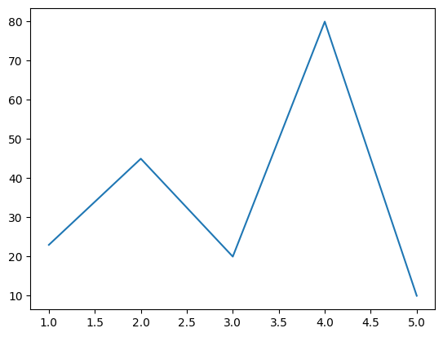

**Code:**

runs=np.array([100,50,91,78,89,25,34,19,9,10])

wickets=np.array([1,0,2,0,3,7,8,9,7,5])

plt.scatter(runs,wickets,color ="purple")#r,b,k,g,m,w,c,y,pink,orange,..

plt.show()

**Output:**

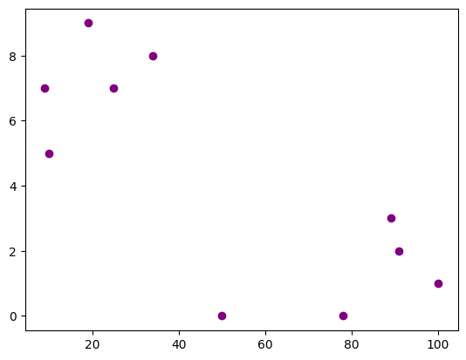

**Code:**

A=[23,45,20,80,10]#carona cases in first 5 days

B=[1,2,3,4,5]

plt.plot(B,A,linestyle="-.")

plt.show()

**Output:**

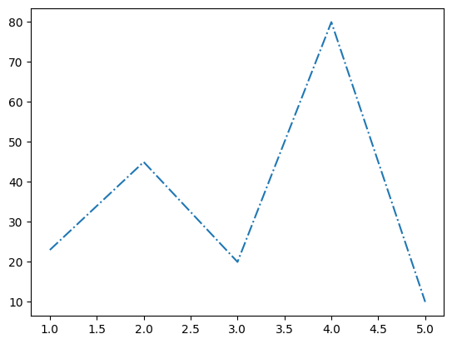

**Code:**

runs=np.array([100,50,91,78,89,25,34,19,9,10])

wickets=np.array([1,0,2,0,3,7,8,9,7,5])

plt.scatter(runs,wickets,color ="black",marker=’H’)

plt.show()

**Output**:

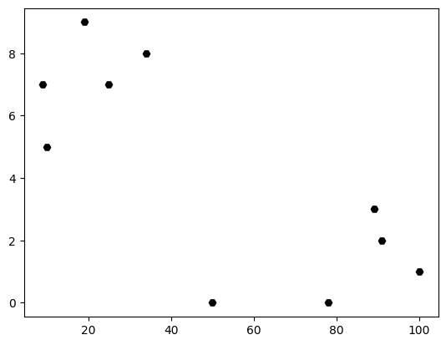

**problem:**show the score comparison of 2 students in 5 different subjects,subjects as x-axis,marks as y-axis

Code:

#plot the scores of 2 students in 5 different subjects, subjects as x-axis and marks as y axis

stud1=[10,20,24,35,50]

stud2=[12,34,25,44,48]

sub=["telugu","hindi","english","maths","science"]

plt.plot(sub,stud1,label="student1",color="blue")

plt.plot(sub,stud2,label="student2",color="black")

plt.title("marks vs subjects")

plt.legend()

**Output:**

**<matplotlib.legend.Legend at 0x799c71b8ed10>**

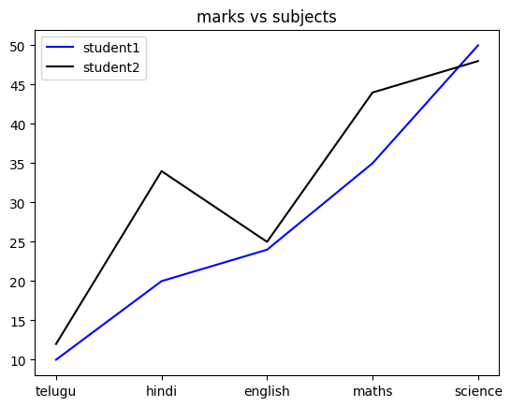

**Code:**

stud1=[10,20,24,35,50]

stud2=[12,34,25,44,48]

sub=["telugu","hindi","english","maths","science"]

plt.subplot(2,1,1)#subplot(rows,columns,positions)

plt.plot(sub,stud1,label="student1",color="blue")

plt.legend()

plt.subplot(2,1,2)

plt.plot(sub,stud2,label="student2",color="black")

plt.title("marks vs subjects")

plt.legend()

**Output:**

**<matplotlib.legend.Legend at 0x799c71a73b80>**

Problem3:

Create Subplots(b←) showing the profits of two companies. year. A BProblem3:

Create Subplots(b←) showing the profits of two companies. year. A B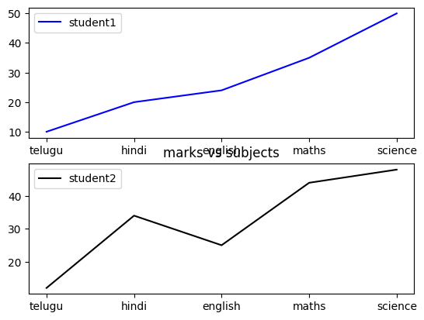

**Code:**

revA=np.array([230,560,780,127,128])

revB=np.array([200,160,270,127,400])

profitC=np.diff(revA)

print(profitC)

profitD=np.diff(revB)

print(profitD)

year=["2019-2020","2020-2021","2021-2022","2022-2023"]

plt.subplot(1,2,1)

plt.bar(year,profitC,label="company 1",color="black")

plt.legend()

plt.subplot(1,2,2)

plt.bar(year,profitD,label="company 2",color="green")

plt.legend()

**Output:**

[ 330 220 -653 1]

[ -40 110 -143 273]

**<matplotlib.legend.Legend at 0x799c6f18c400>**

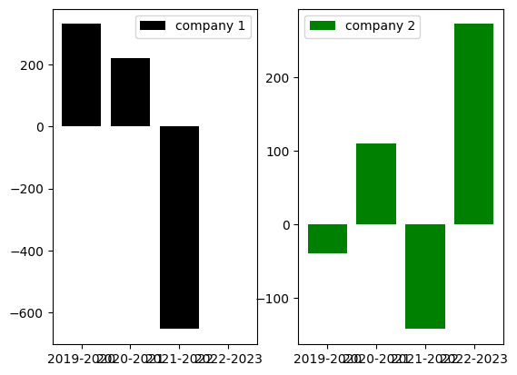

**Pie chart:**

**Code:**

#syntax:pie(values,labels=label_name)

#n(values)=n(labels)

A=np.array([25,40,35,10])

labe=["python","AIML","Cloud","numpy"]

plt.pie(A,labels=labe)

**Output:**

**([<matplotlib.patches.Wedge at 0x799c6f2cfb20>,**

**<matplotlib.patches.Wedge at 0x799c6f2cdb70>,**

**<matplotlib.patches.Wedge at 0x799c6f2ce350>,**

**<matplotlib.patches.Wedge at 0x799c6f2cc2e0>],**

**[Text(0.8313245164615624, 0.7203468250294088, 'python'),**

**Text(-0.9253789316708985, 0.5947048283136995, 'AIML'),**

**Text(1.0298943251329445e-07, -1.0999999999999954, 'Cloud'),**

**Text(1.055442297353649, -0.30990572269135586, 'numpy')])**

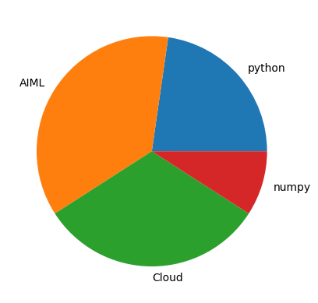

**Code:**

A=np.array([25,40,35,10])

labe=["python","AIML","Cloud","numpy"]

explo=[0.2,0,0,0]

plt.pie(A,labels=labe,explode=explo,startangle=180)

plt.show()

**Output:**

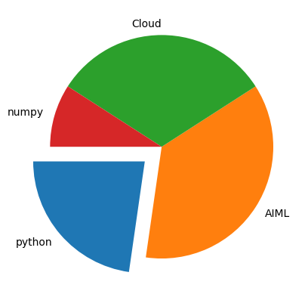

**Code:**

**A=np.array([25,40,35,10])**

**labe=["python","AIML","Cloud","numpy"]**

**explo=[0.2,0,0,0]**

**plt.pie(A,labels=labe,explode=explo,startangle=180,shadow=True)**

**plt.legend()**

**plt.show()**

**Output:**

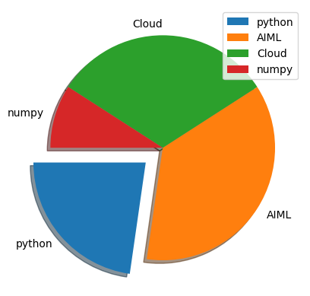

**Pandas:**

* Used for data manipulation.
* Create dataframes from excel,csv,txt,DBs.
* Dataframes(rows and columns readable by python).
* Data cleaning by dropping or replacing with mean.
* visualise the data.

**3.1.Importing:**

**Code:**

import pandas as pd

**SERIES:**

**Code:**

names=["neha","vyshu","divya","gopi","vasavi"]

index=[10,20,30,40,50]

ser1=pd.Series(names,index)

print(ser1)

**Output:**

10 neha

20 vyshu

30 divya

40 gopi

50 vasavi

dtype: object

**Importing Files:**

* For csv and txt :read_csv
* For excel : read_excel

**Code:**

df=pd.read_csv("/content/liver patients.csv")

df.head(10)

**Output:**

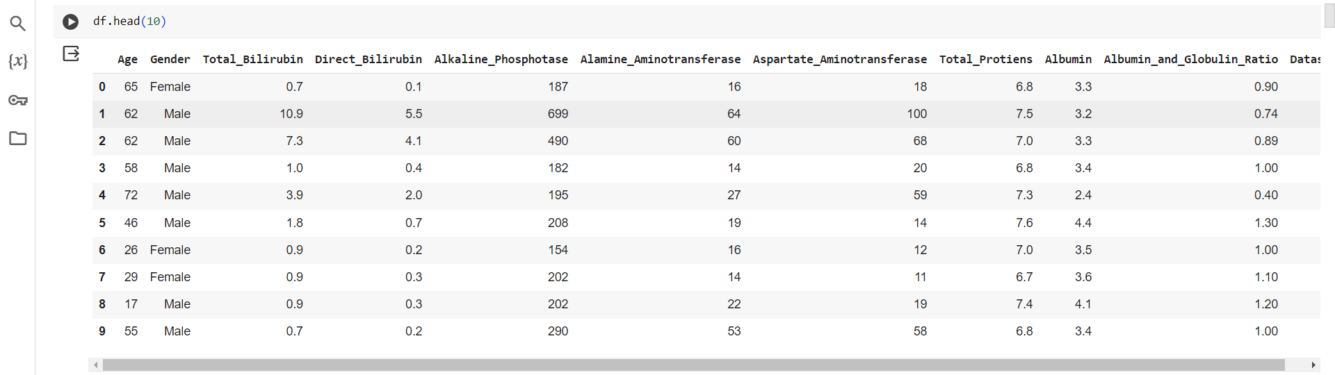

**Code:**

df=pd.read_csv("/content/grades.txt",sep=",")

df.head()

**Output:**

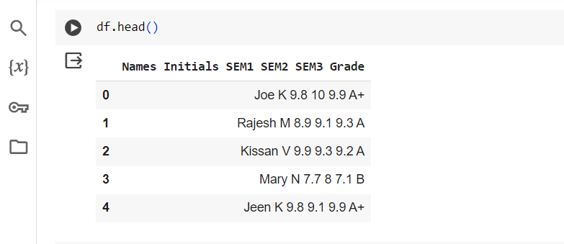

**Code:**

dft=pd.read_excel("/content/iris.xlsx")

dft.head()

**Output:**

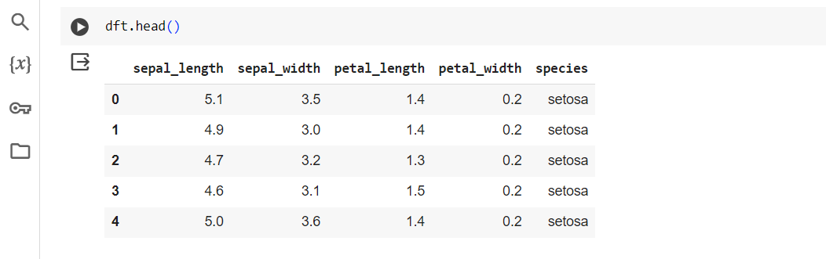

**3.2. Describe**:

**Code:**

dft=pd.read_excel("/content/iris.xlsx")

print(dft.describe)

**Output:**

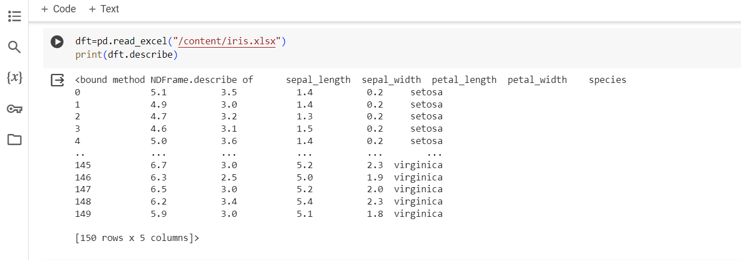

**Code:**

df=pd.read_csv("/content/liver patients.csv")

print(df.shape)#get the number of rows and columns

print(df.shape[0])#Get the number of rows only

print(df.shape[1])#get the number of columns only

**Output:**

**(583, 11)**

**583**

**11**

**3.3.Accessing data:**

* **loc-accepts column names and index**
* **iloc-accepts only index**

**Code:**

print(dft.columns)

**Output:**

Index(['sepal_length', 'sepal_width', 'petal_length', 'petal_width','species'],dtype='object')

**Code:**

print(dft[2:6])#number of rows

**Output:**

**sepal_length sepal_width petal_length petal_width species**

**2 4.7 3.2 1.3 0.2 setosa**

**3 4.6 3.1 1.5 0.2 setosa**

**4 5.0 3.6 1.4 0.2 setosa**

**5 5.4 3.9 1.7 0.4 setosa**

**Code:**

print(dft.loc[2:5,"species"])

**Output:**

**2 setosa**

**3 setosa**

**4 setosa**

**5 setosa**

**Name: species, dtype: object**

**Code:**

print(df.iloc[2:5])#rows of specified columns

**Output:**

**Age Gender Total_Bilirubin Direct_Bilirubin Alkaline_Phosphotase \**

**2 62 Male 7.3 4.1 490**

**3 58 Male 1.0 0.4 182**

**4 72 Male 3.9 2.0 195**

**Alamine_Aminotransferase Aspartate_Aminotransferase Total_Protiens \**

**2 60 68 7.0**

**3 14 20 6.8**

**4 27 59 7.3**

**Albumin Albumin_and_Globulin_Ratio Dataset**

**2 3.3 0.89 1**

**3 3.4 1.00 1**

**4 2.4 0.40 1**

**Code:**

print(dft.iloc[2:5, :3]) #iloc[row range,column range]=>index

**Output:**

**sepal_length sepal_width petal_length**

**2 4.7 3.2 1.3**

**3 4.6 3.1 1.5**

**4 5.0 3.6 1.4**

**Code:**

dft=pd.read_csv("/content/grades_withnulls.csv")

dft.head(16)

**Output:**

|  |  |  |  |  |  |  |  |
| --- | --- | --- | --- | --- | --- | --- | --- |
| **Names** | **Initials** | **SEM1** | **SEM2** | **SEM3** | **Grade** | **Placed** |  |
| **0** | **Joe** | **K** | **9.8** | **10.0** | **9.9** | **A+** | **1** |
| **1** | **Rajesh** | **M** | **8.9** | **9.1** | **9.3** | **A** | **1** |
| **2** | **Kissan** | **V** | **9.9** | **9.8** | **10.0** | **A** | **0** |
| **3** | **Mary** | **N** | **7.7** | **8.0** | **NaN** | **B** | **0** |
| **4** | **Jeen** | **K** | **9.8** | **9.1** | **9.9** | **A+** | **1** |
| **5** | **Raj** | **M** | **8.9** | **9.1** | **9.3** | **A** | **1** |
| **6** | **Hassan** | **V** | **9.9** | **9.0** | **9.2** | **A** | **1** |
| **7** | **Mari** | **N** | **7.7** | **8.0** | **7.1** | **B** | **1** |
| **8** | **Jess** | **K** | **NaN** | **9.1** | **9.9** | **A+** | **1** |
| **9** | **Rajini** | **M** | **NaN** | **9.1** | **9.3** | **A** | **0** |
| **10** | **Kiran** | **V** | **NaN** | **9.3** | **9.2** | **A** | **0** |
| **11** | **Maya** | **N** | **7.7** | **8.0** | **7.1** | **B** | **0** |
| **12** | **Jolin** | **K** | **9.8** | **9.1** | **9.9** | **A+** | **1** |
| **13** | **Rajesh** | **M** | **8.9** | **9.1** | **9.3** | **A** |  |
| **14** | **Riya** | **M** | **9.3** | **9.9** | **10.0** | **A** | **1** |
| **15** | **Sana** | **V** | **9.9** | **9.3** | **9.2** | **A** | **0** |

**Code:**

dft.isnull()

**Output:**

| **Names** | **Initials** | **SEM1** | **SEM2** | **SEM3** | **Grade** | **Placed** |  |
| --- | --- | --- | --- | --- | --- | --- | --- |
| **0** | **False** | **False** | **False** | **False** | **False** | **False** | **False** |
| **1** | **False** | **False** | **False** | **False** | **False** | **False** | **False** |
| **2** | **False** | **False** | **False** | **False** | **False** | **False** | **False** |
| **3** | **False** | **False** | **False** | **False** | **True** | **False** | **False** |
| **4** | **False** | **False** | **False** | **False** | **False** | **False** | **False** |
| **5** | **False** | **False** | **False** | **False** | **False** | **False** | **False** |
| **6** | **False** | **False** | **False** | **False** | **False** | **False** | **False** |
| **7** | **False** | **False** | **False** | **False** | **False** | **False** | **False** |
| **8** | **False** | **False** | **True** | **False** | **False** | **False** | **False** |
| **9** | **False** | **False** | **True** | **False** | **False** | **False** | **False** |
| **10** | **False** | **False** | **True** | **False** | **False** | **False** | **False** |
| **11** | **False** | **False** | **False** | **False** | **False** | **False** | **False** |
| **12** | **False** | **False** | **False** | **False** | **False** | **False** | **False** |
| **13** | **False** | **False** | **False** | **False** | **False** | **False** | **False** |
| **14** | **False** | **False** | **False** | **False** | **False** | **False** | **False** |
| **15** | **False** | **False** | **False** | **False** | **False** | **False** | **False** |
| **16** | **False** | **False** | **False** | **False** | **False** | **False** | **False** |

**Code:**

dft.isnull().sum()

**Output:**

**Names 0**

**Initials 0**

**SEM1 3**

**SEM2 0**

**SEM3 1**

**Grade 0**

**Placed 0**

**dtype: int64**

**Code:**

dft.isnull().sum().sum()#to view total nulls

**Output:**

4

**Dropping:**

**3.4.dropna:**

(It is a function used to remove rows or columns with missing values ( NaN ) from a DataFrame

**Code:**

dft.dropna()#dropping all the rows with nulls

**Output:**

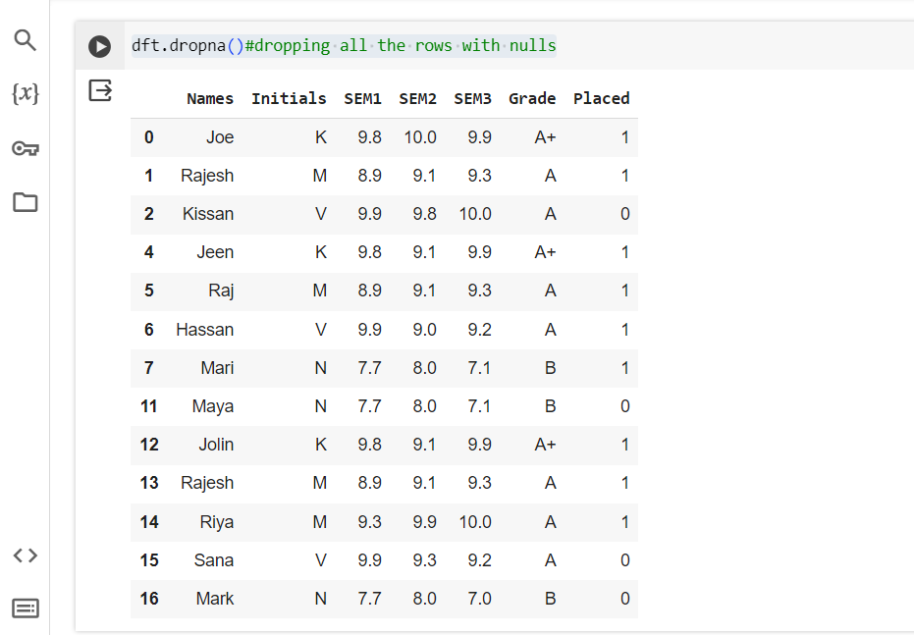

**Code:**

dftc=dft.dropna()

dftc

Output:

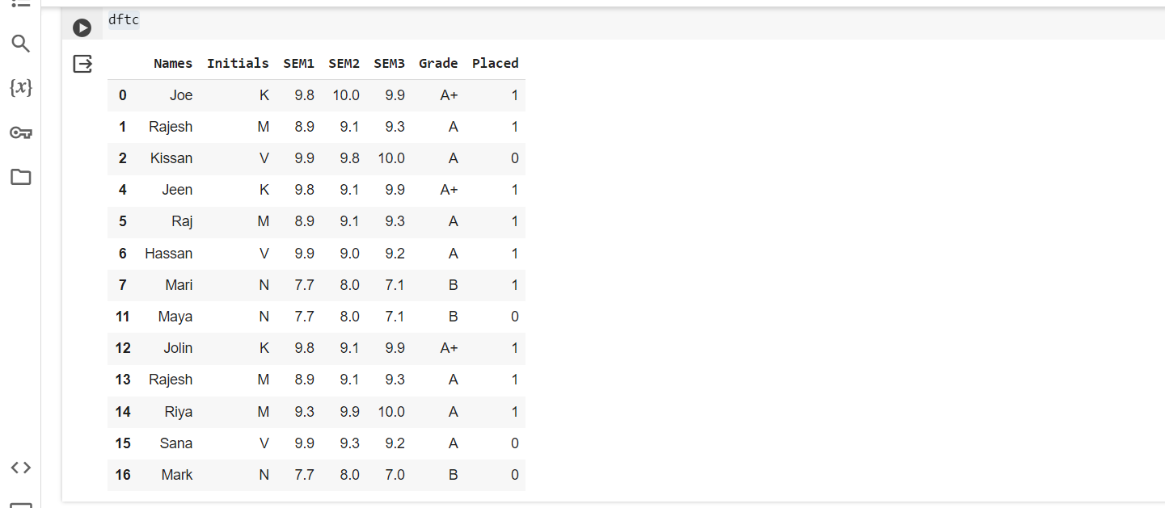

**3.5 fullna():**

You can use the fillna() function to fill the null values in the dataset.

**Code:**

dft.fillna(5)

**Output:**

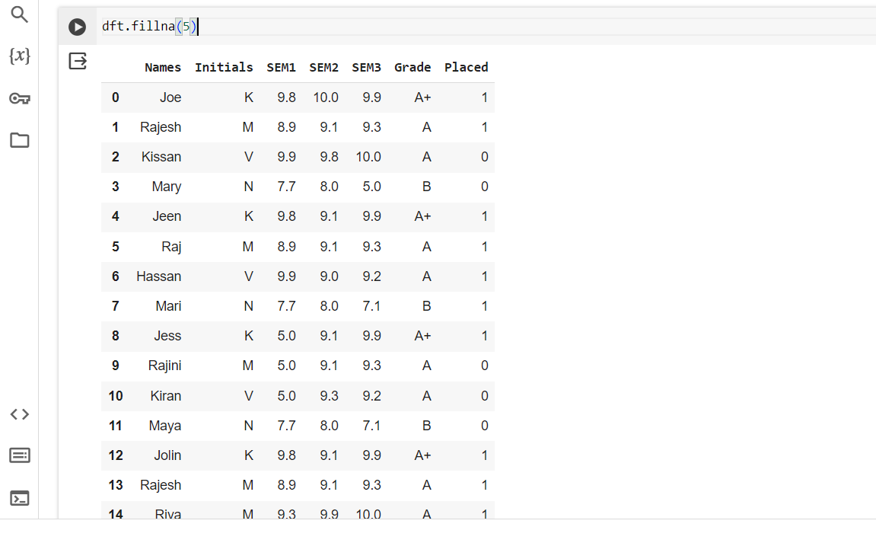

**3.6. Cleaning with mean:**

**Code:**

m=dft['SEM3'].mean()

print(m)

**Output:**

9.100000000000001

**Code:**

dftc2=df.fillna(m)

print(dftc2)

**Output:**

Names Initials SEM1 SEM2 SEM3 Grade Placed

0 Joe K 9.8 10 9.9 A+ 1

1 Rajesh M 8.9 9.1 9.3 A 1

2 Kissan V 9.9 9.8 10 A 0

3 Mary N 7.7 8 NaN B 0

4 Jeen K 9.8 9.1 9.9 A+ 1

5 Raj M 8.9 9.1 9.3 A 1

6 Hassan V 9.9 9 9.2 A 1

7 Mari N 7.7 8 7.1 B 1

8 Jess K NaN 9.1 9.9 A+ 1

9 Rajini M NaN 9.1 9.3 A 0

10 Kiran V NaN 9.3 9.2 A 0

11 Maya N 7.7 8 7.1 B 0

12 Jolin K 9.8 9.1 9.9 A+ 1

13 Rajesh M 8.9 9.1 9.3 A 1

14 Riya M 9.3 9.9 10 A 1

15 Sana V 9.9 9.3 9.2 A 0

16 Mark N 7.7 8 7 B 0

**3.7. Dropping Duplicates:**

The drop_duplicates() method removes duplicate rows**.**

**Code:**

dropped=dftc2.drop_duplicates()

print( dropped )

**Output:**

**Names Initials SEM1 SEM2 SEM3 Grade Placed**

**0 Joe K 9.8 10 9.9 A+ 1**

**1 Rajesh M 8.9 9.1 9.3 A 1**

**2 Kissan V 9.9 9.8 10 A 0**

**3 Mary N 7.7 8 NaN B 0**

**4 Jeen K 9.8 9.1 9.9 A+ 1**

**5 Raj M 8.9 9.1 9.3 A 1**

**6 Hassan V 9.9 9 9.2 A 1**

**7 Mari N 7.7 8 7.1 B 1**

**8 Jess K NaN 9.1 9.9 A+ 1**

**9 Rajini M NaN 9.1 9.3 A 0**

**10 Kiran V NaN 9.3 9.2 A 0**

**11 Maya N 7.7 8 7.1 B 0**

**12 Jolin K 9.8 9.1 9.9 A+ 1**

**13 Rajesh M 8.9 9.1 9.3 A 1**

**14 Riya M 9.3 9.9 10 A 1**

**15 Sana V 9.9 9.3 9.2 A 0**

**16 Mark N 7.7 8 7 B 0**

**Columns:**

**Code:**

dft.rename(columns={"Grade" :"GPA"})#dft.rename(columns= {old:new})

**Output:**

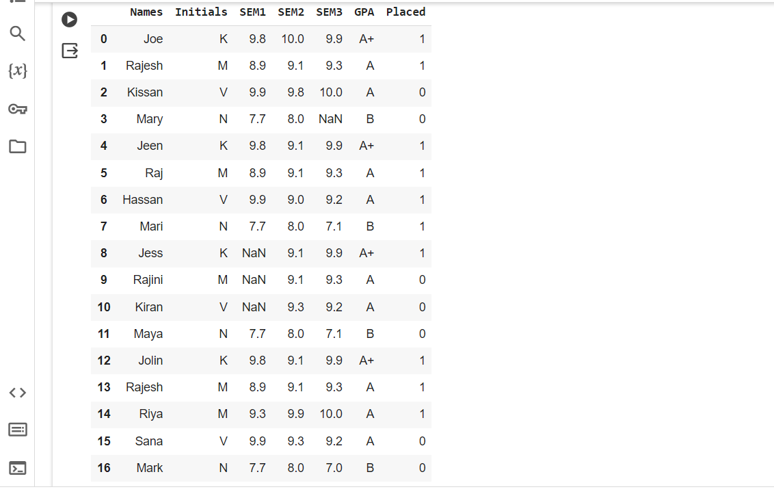

**Code:**

dftc2.rename(columns={"Grade" :"GPA"},inplace=True)#dft.rename(columns= {old:new})

dftc2.head()

**Output:**

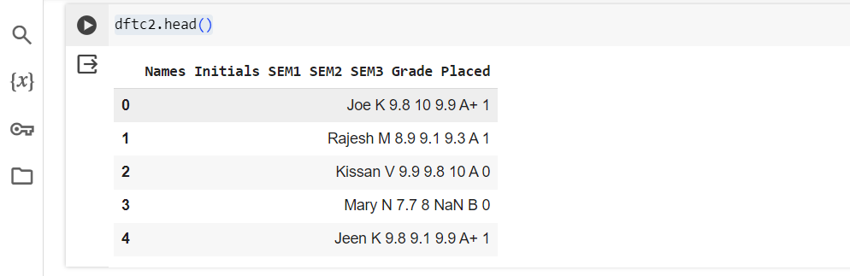

**Code:**

dft['Avg_score'] = (dft['SEM1'] + dft['SEM2'] + dft['SEM3'])/3#DF['NEWCOL']=values

dft.head()

**Output:**

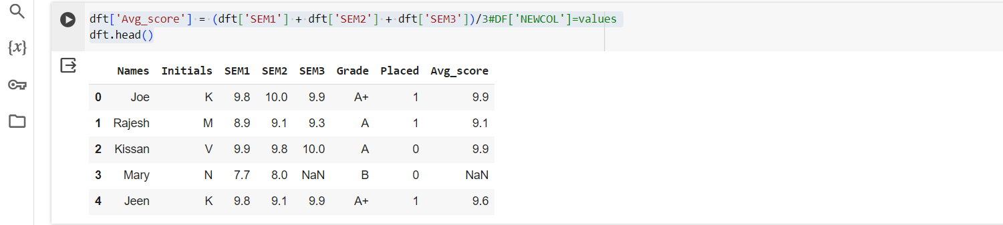

**3.8. Plotting :**

**Code:**

dft[['SEM1','SEM2']].plot.line()

**Output:**

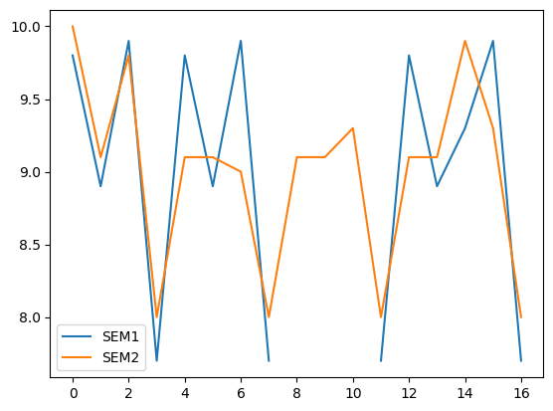

**3.9. Subplots:**

**Code:**

dft.plot.line(subplots=True)

**Output:**

array([<Axes: >, <Axes: >, <Axes: >, <Axes: >, <Axes: >], dtype=object)

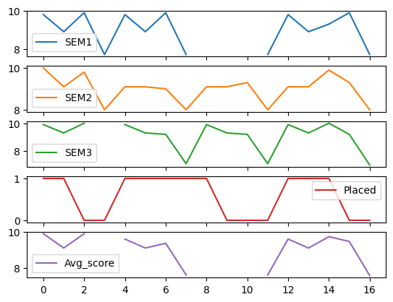

**Seaborn:**

Seaborn is a Python data visualisation library based on matplotlib. It provides a high-level interface for drawing attractive and informative statistical graphics**.**

**4.1 Importing :**

**Code:**

import seaborn as sns

pl=sns.lineplot(x='Names',y='SEM1',data=dft)

**Output:**

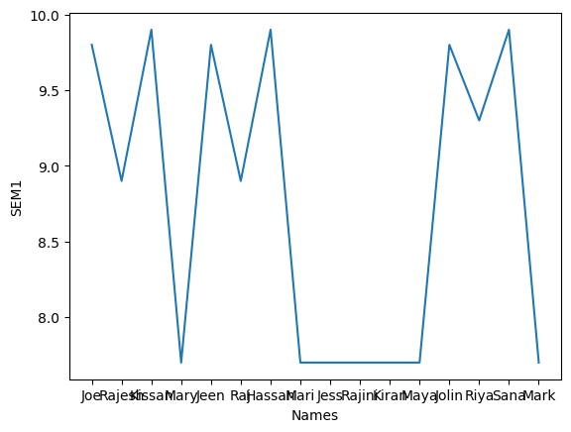

**4.2. Relplot:**

The Seaborn Relational Plot (relplot) allows us to visualise how variables within a dataset relate to each other.

**Code:**

sns.relplot(data=dft,x="SEM2",y="SEM1",col="Names”)

**Output:**

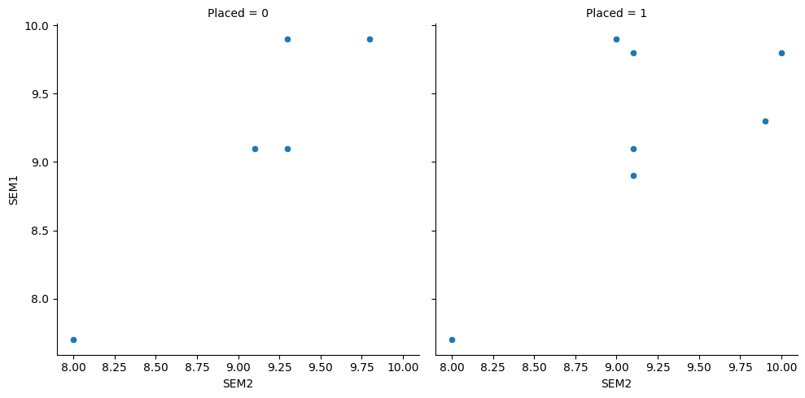

**Problem:**

1. Load diabets.csv
2. create relplot with age in the x axis and class as columns

**Code:**

ds=pd.read_csv("/content/diabetcsv.csv")

ds.head()

H=ds.columns

print(H)

**Output:**

Index(['preg', 'plas', 'pres', 'skin', 'insu', 'mass', 'pedi', 'age', 'class'], dtype='object')

**Code:**

ds['index']=range(1,769)#creating indexes

ds

sns.relplot(data=ds,x="index",y="age",col="class")

**Output:**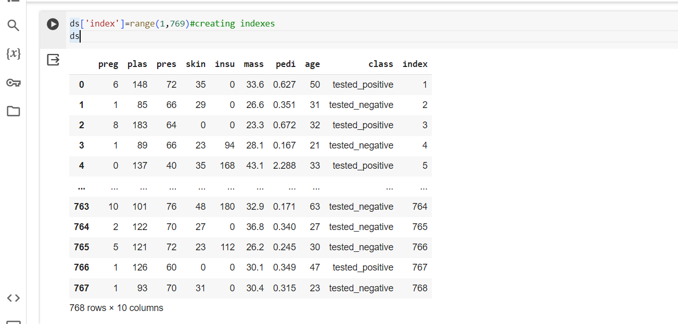

<seaborn.axisgrid.FacetGrid at 0x79f338209c00>

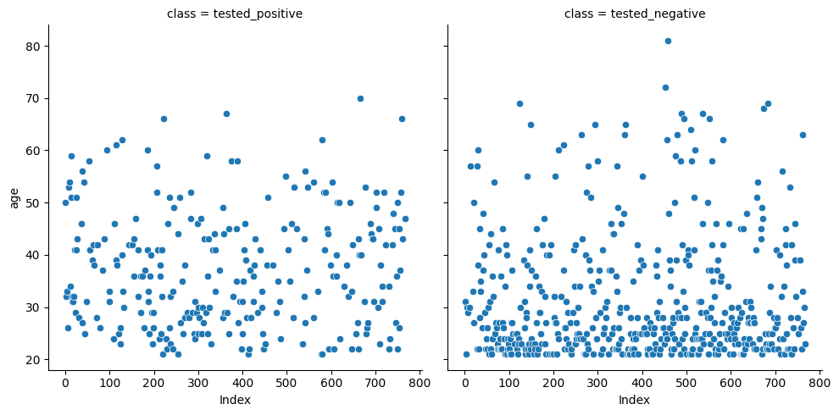

**In-built datasets in seaborn:**

* tips
* dowjones
* fmri
* dots
* health exp
* To load datasets use:=>load_datasets("dataset_name")

hue = different colour for diff category style=different colour for diff marker

**Code:**

import seaborn as sns

tips=sns.load_dataset("tips")

tips.head()

**Output:** 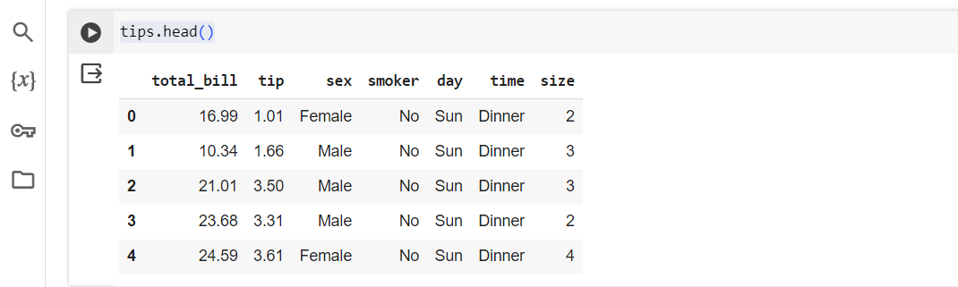

**Code:**

fmri=sns.load_dataset("fmri")

fmri.head()

**Output:**

| **subject** | **timepoint** | **event** | **region** | **signal** |  |
| --- | --- | --- | --- | --- | --- |
| **0** | s13 | 18 | stim | parietal | -0.017552 |
| **1** | s5 | 14 | stim | parietal | -0.080883 |
| **2** | s12 | 18 | stim | parietal | -0.081033 |
| **3** | s11 | 18 | stim | parietal | -0.046134 |
| **4** | s10 | 18 | stim | parietal | -0.037970 |

**Code:**

sns.relplot(data=tips,x="total_bill",y="tip")

**Output:**

**<seaborn.axisgrid.FacetGrid at 0x79b7febc75e0>**

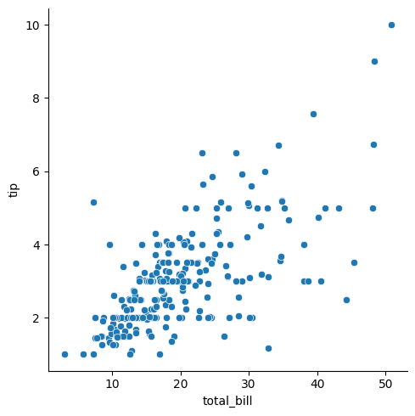

**Code:**

sns.relplot(data=tips,x="total_bill",y="tip",hue="smoker"**)**

**Output:**

<seaborn.axisgrid.FacetGrid at 0x79b7c3c57f40>

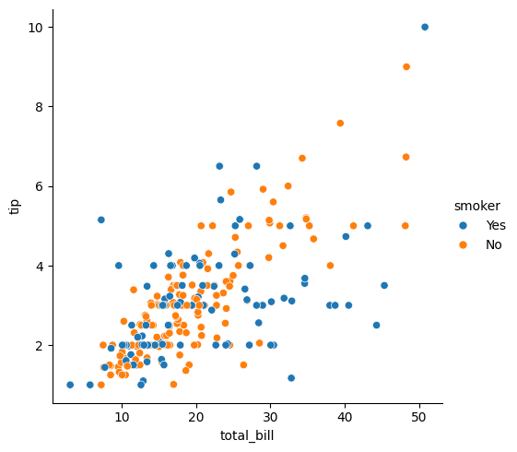

**Code:**

sns.relplot(data=tips,x="total_bill",y="tip",hue="time")

**Output:**

<seaborn.axisgrid.FacetGrid at 0x79b7c39af4f0>

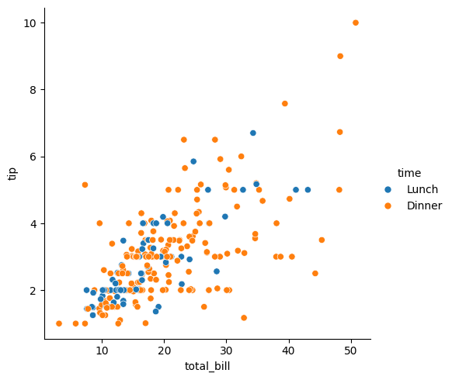

* subject means patient number
* region=brain location

**Code:**

sns.relplot(data=tips,x="total_bill",y="tip",hue="day")

**Output:**

<seaborn.axisgrid.FacetGrid at 0x79b7c39aec50>

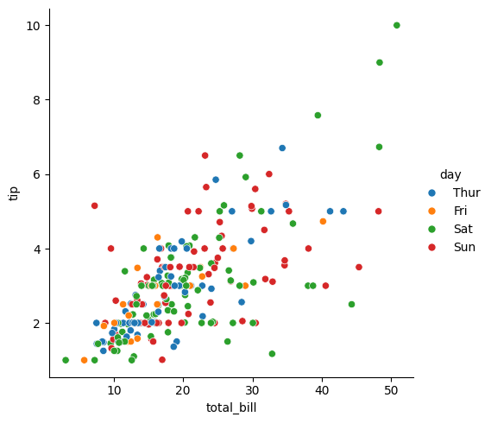

* hue-> different color for different cat
* style->differerent color for different marker

**Color Palette:**

* pastel
* bright
* dark
* muted
* color blind
* Deep

**Code:**

sns.relplot(data=tips,x="total_bill",y="tip",hue="day",style="time")

**Output:**

<seaborn.axisgrid.FacetGrid at 0x79b7c392f310>

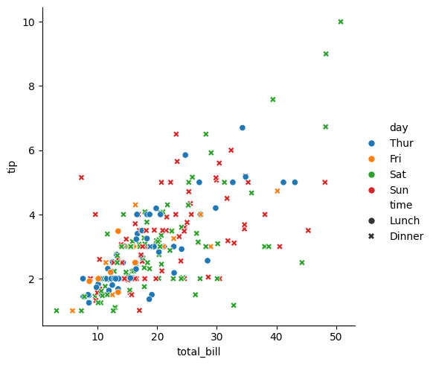

**Code:**

dowjones=sns.load_dataset("dowjones")

dowjones.head()

**Output:**

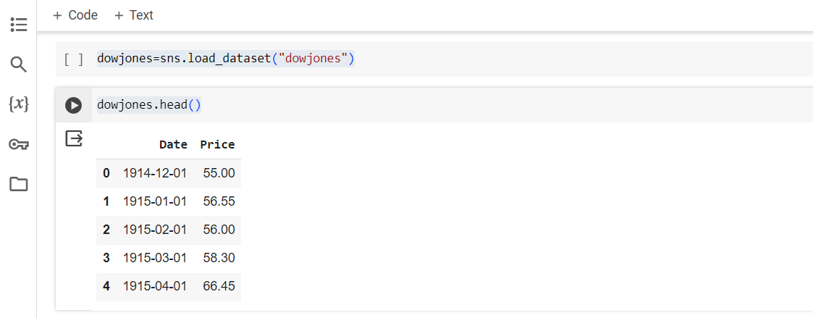

**Code:**

sns.relplot(data=dowjones,x="Date",y="Price",kind="line")

**Output:**

<seaborn.axisgrid.FacetGrid at 0x79b7c1c6d8a0>

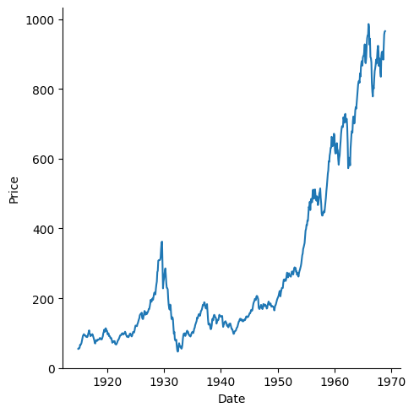

**Code:**

fmri=sns.load_dataset("fmri")

fmri.head()

**Output:**

| **subject** | **timepoint** | **event** | **region** | **signal** |  |
| --- | --- | --- | --- | --- | --- |
| **0** | s13 | 18 | stim | parietal | -0.017552 |
| **1** | s5 | 14 | stim | parietal | -0.080883 |
| **2** | s12 | 18 | stim | parietal | -0.081033 |
| **3** | s11 | 18 | stim | parietal | -0.046134 |
| **4** | s10 | 18 | stim | parietal | -0.037970 |

**Code:**

fmri=sns.load_dataset(“fmri”)

sns.relplot(data=fmri,x=”timepoint”,y=”signal”,hue=”event”,style=”subject”)

**Output:**

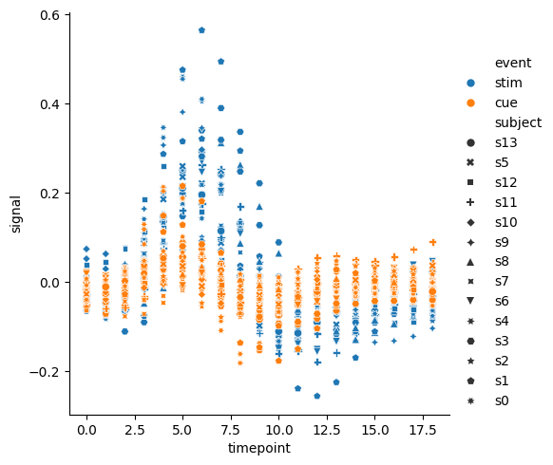

**Category plot :** The Seaborn catplot() function is used to create figure-level relational plots onto a Seaborn FacetGrid.

**Code:**

sns.catplot(data=tips,x="total_bill",y='day')

**Output:**

**<seaborn.axisgrid.FacetGrid at 0x79b7febd93f0>**

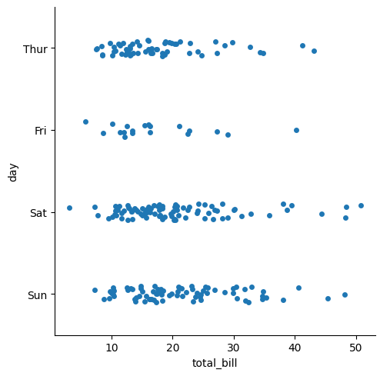

**Code:**

sns.catplot(data=fmri,x="region",y='timepoint',kind="violin")

**Output**:

<seaborn.axisgrid.FacetGrid at 0x79b7c39af190>

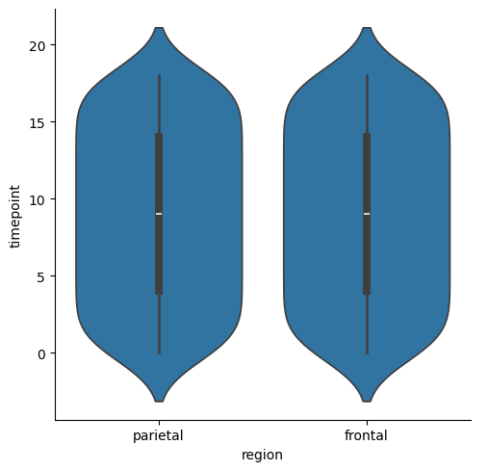

**Code:**

sns.catplot(data=tips,y="total_bill",x='time',kind="violin",hue="smoker")

**Output:**

<seaborn.axisgrid.FacetGrid at 0x79b7c3c71090>

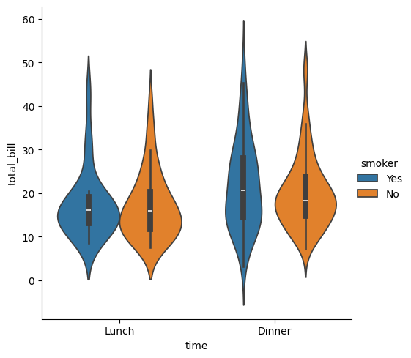

**Linear fit**

* lmplot()

**STEPS FOR LINEAR FIT:**

* plotting the dataset
* fitting the line
* predicting

lmplot() method is used to draw a scatter plot onto a FacetGrid.

**Code:**

sns.lmplot(x="size",y="tip",data=tips);

**Output:**

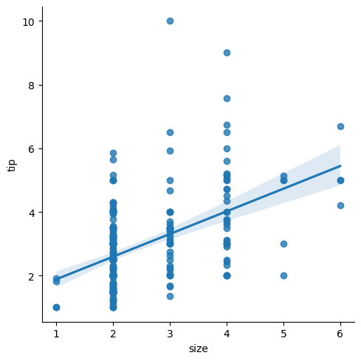

**Code:**

sns.lmplot(x="signal",y="timepoint",data=fmri);

**Output:**

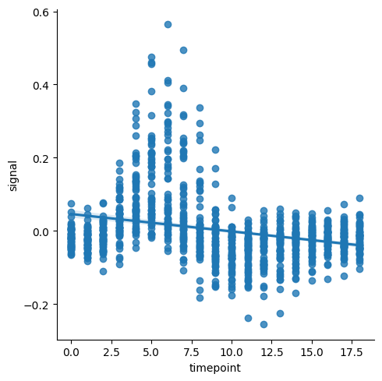

**Web Scraping:**

* Loading data from a website.
* Unstructured in html.
* Convertible into spreadsheets/DB.
* Major websites have their APIs for web scraping.

**Scrapper:**

* Extract all the data on particular sites.
* Specific data that a user wants.

**Process:**

* URL->
* HTML code->
* Elements (CSS/JS)->
* Scrapes the required data->
* Saves it in required format(cvs,xlsx,Json)

**Applications:**

* Email Marketing.
* Sentiment Analysis.
* News Monitoring.
* Market Research.
* Price Monitoring.

**Libraries:**

* BeautifulSoup - scoop outs the html code -bs4 library
* Requests - to access the webpage - get(url)
* Selenium -
* Pandas - create data frames from excel,texts,cvs,DBs
* webdriver
* webdriver_manager

To install any library:

**!pip install library**

**!pip install –upgrade library** #to upgrade to recent version

Import subpage:

from parent import child

Ex:- from bs4 import beautifulsoup

**Beautifulsoup:**

-Used to scrape data from static website

- Package bs4: subpackage BeautifulSoup

| **Function** | **Purpose** | **Attributes** |
| --- | --- | --- |
| BeautifulSoup() | To extract html code from a web page | .text  html |
| find() | To find first element of a kind | (‘element_name) |
| find_all() | To find all elements of a kind | (‘element_name) |

**Requests:**

-Used to send the request to a web page

-get(‘url’)

**Project 1:**

**Extracting HTML code of any website**

Program flow

1. Import libraries
2. Save the url
3. Using request.get(),access the the web page
4. Using BeautifulSoup(),access HTML code

Step-1

#import libraries

from bs4 import BeautifulSoup

import requests

import pandas as pd

Step-2

#save the url

url=("https://en.wikipedia.org/wiki/MS_Dhoni")

Step-3

#using requests.get(),access the webpage

req=requests.get(url)

Step-4

#access the html code

S=BeautifulSoup(req.text,"html")

print(S)

**Output:**

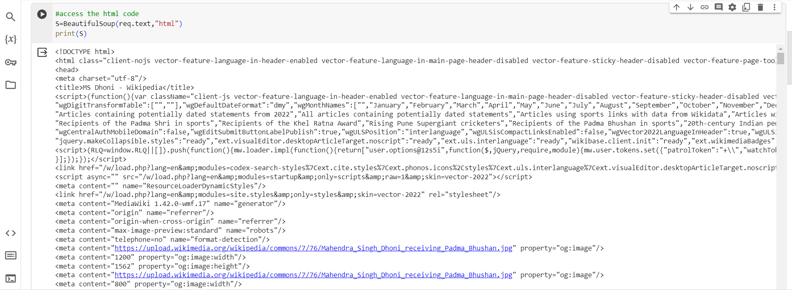

**``Accessing Elements:**

* Go to webpage
* Right click →Inspect
* Click on 
* Now hover on the element you want to access
* The html tags/code for that specific element is highlighted
* Extract the element name and import in your program using XPATH or By ID.

**Project 2 :**

**Extracting a table from HTML code of any website and saving it as.csv file**

Program flow

1. Import libraries
2. Save the url
3. Using requests.get(),access the web page
4. Using BeautifulSoup(),access the html code
5. Using find,access the table
6. Using find_all,access the rows of the table
7. Using.text,extract only the text(removing html page)
8. Create a dataframe using pandas
9. Push all the extracted data into dataframes
10. Using to_csv, save the dataframe in csv format.

Step-1

#import libraries

from bs4 import BeautifulSoup

import requests

import pandas as pd

Step-2

url2=("https://www.forbesindia.com/article/explainers/top-10-richest-people-india/85909/1")

Step-3

req2=requests.get(url2)

Step-4

A=BeautifulSoup(req2.text,"html")

print(A)

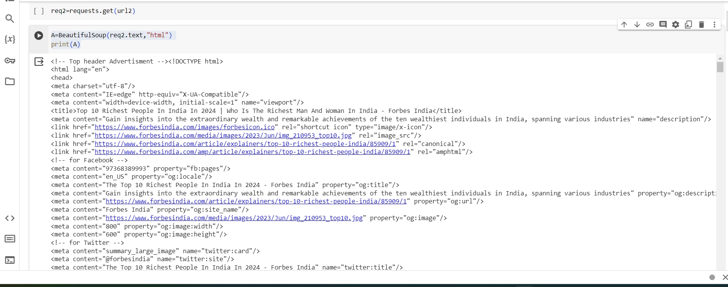

Step-5

#th=table head,tr=table row,tablebody=body of table,table=whole table

#using find access table

table=A.find('table')

print(table)

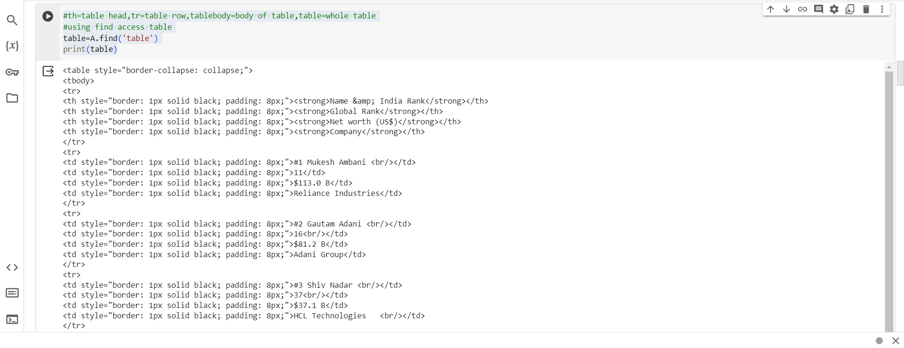

Step-6

rows=table.find_all('tr')

print(rows)

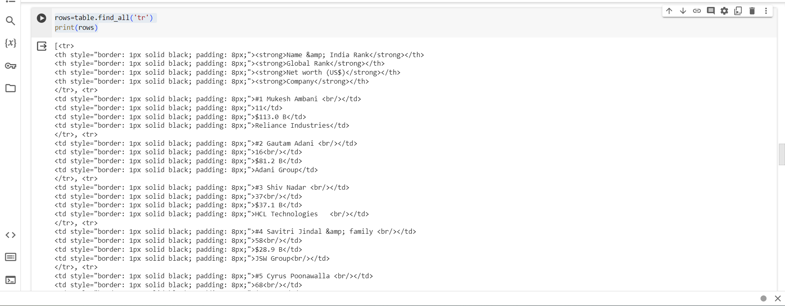

Step-7

rows=table.find_all('tr')

for i in rows[1:9]:

rd=i.find_all('td')

eachrow=[i.text for i in rd]

print(eachrow)

**Output:**

['#1 Mukesh Ambani ', '11', '$113.0 B', 'Reliance Industries']

['#2 Gautam Adani ', '16', '$81.2 B', 'Adani Group']

['#3 Shiv Nadar ', '37', '$37.1 B', 'HCL Technologies\xa0\xa0 ']

['#4 Savitri Jindal & family ', '58', '$28.9 B', 'JSW Group']

['#5 Cyrus Poonawalla ', '68', '$25.6 B', 'Serum Institute of India']

['#6 Dilip Shanghvi ', '69', '$25.5 B', 'Sun Pharmaceutical Industries Ltd']

['#7 Kumar Birla ', '97', '$18.9 B', 'Aditya Birla Group']

['#8 Kushal Pal Singh', '98', '$18.9 B', 'DLF Limited']

Step-8

#using find_all,access the headings of table

headings=table.find_all('th')

print(headings)

**Output:**

[<th style="border: 1px solid black; padding: 8px;"><strong>Name &amp; India Rank</strong></th>, <th style="border: 1px solid black; padding: 8px;"><strong>Global Rank</strong></th>, <th style="border: 1px solid black; padding: 8px;"><strong>Net worth (US$)</strong></th>, <th style="border: 1px solid black; padding: 8px;"><strong>Company</strong></th>]

**Code:**

headings=table.find_all('th')

head=[i.text for i in headings]#list comprehension

print(head)

**Output:**

['Name & India Rank', 'Global Rank', 'Net worth (US$)', 'Company']

Step-9

a=0

for i in rows[1:9]:

er=i.find_all('td')

eachrow=[i.text for i in er]

df.loc[a]=eachrow

a=a+1

Output:

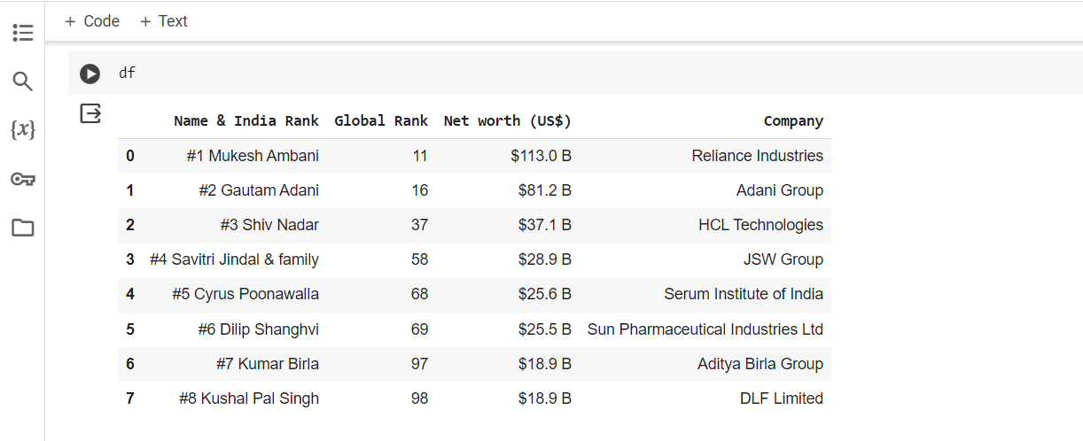

Step-10

df.to_csv("rich people.csv"

**Output:**

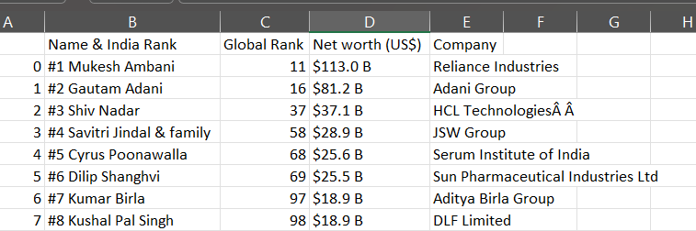

**Selenium:**

* Used to scrape data from static website
* Subpackage:Webdriver

| Function | Purpose | Attributes |
| --- | --- | --- |
| ChromeOptions() | Creates an instance of Chrome |  |
| .get | Access a webpage | ‘url’ |
| find_element | To find first element of a kind | By.ID  By.XPATH |
| .click | To click a button in webpage |  |

**Problem 3:**

**Extracting Dell laptops from amazon in website and saving it as .csv**

**Name of the Laptop , Price , No of Reviews.**

* To access the search box in amazon →id twotosearchtextbox
* To access the search button →id nav-search-submit-button

Step-1:

!pip install selenium

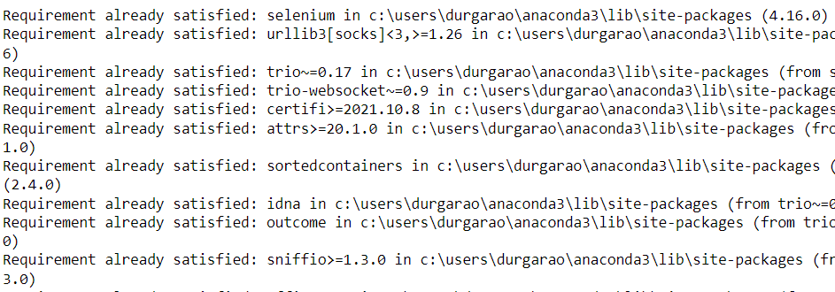

!pip install webdriver_manager

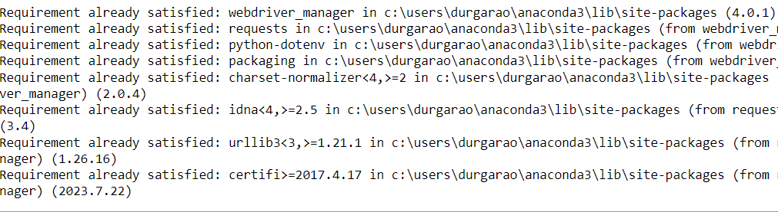

Step-2

from selenium import webdriver

from selenium.webdriver.chrome.options import Options

from webdriver_manager.chrome import ChromeDriverManager

from selenium.webdriver.common.by import By

from selenium.webdriver.common.keys import Keys

Step-3

#define options and set browser capabilities

options=webdriver.ChromeOptions()

options.add_argument('--some-option')

#Create WebDriver instance with options

driver=webdriver.Chrome(options=options)

#Access browser capabilities

browser_name=options.to_capabilities()['browserName']

print(browser_name)

**Output:**

chrome



Step-4

#Navigate to a website

driver.get('https://www.amazon.in/')



Step-5

search=driver.find_element(By.ID,"twotabsearchtextbox")

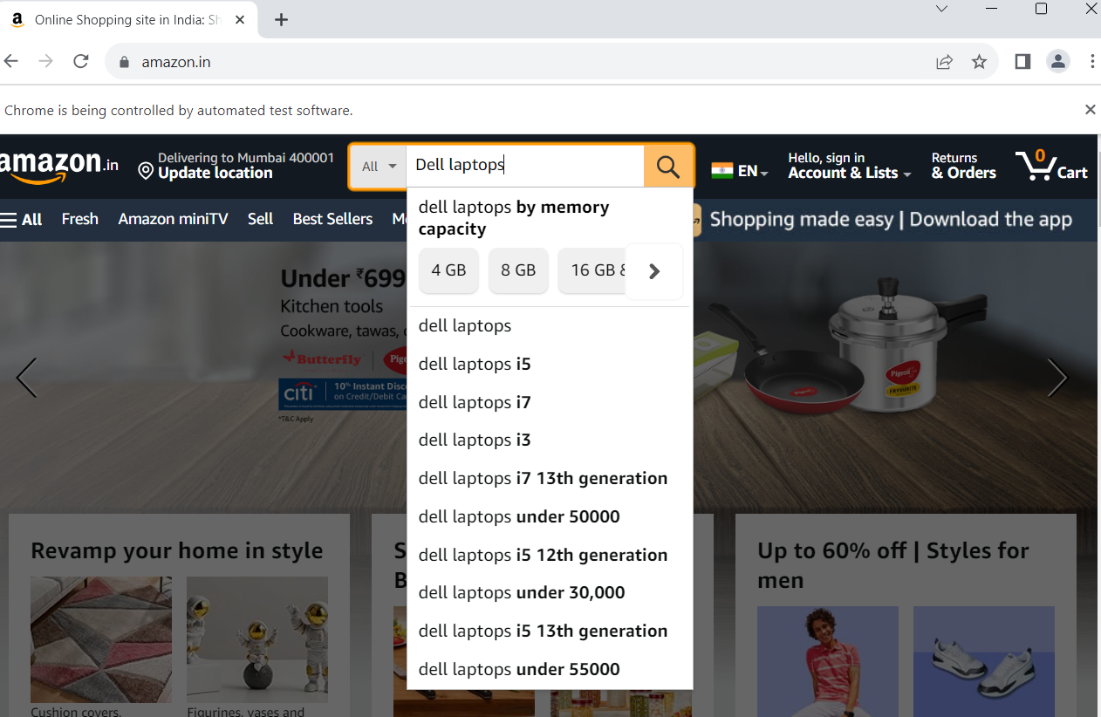

Step-6

driver.find_element(By.ID,"nav-search-submit-button").click()



Step-7:driver.find_element(By .XPATH,"//span[text()='Dell']").click()



Step-8

names=driver.find_elements(By .XPATH,"//span[@class='a-size-medium a-color-base a-text-normal']")

laptop_name=[i.text for i in names]

print(laptop_name)

Output:

['Dell 14 Laptop, AMD Ryzen R5-5500U/ 8GB DDR4, 2400 MHz/ 512GB/ 14.0" (35.56cm) FHD Display with Comfort View/Windows 11 + MSO\'21/15 Month McAfee/Spill-Resistant Keyboard/Carbon Black/ 1.48kg', 'Dell Inspiron 3520 Laptop, Intel Core i5-1235U Processor, 16GB,512GB,15.6" (39.62cm) FHD Display, Backlit Keyboard, Win 11 + MSO\'21,15 Month McAfee, Silver, Thin & Light-1.65kg', 'Dell 14 Laptop, 12th Gen Intel Core i3-1215U Processor/8GB/512GB SSD/Intel UHD Graphics/14.0"(35.56cm) FHD/Windows 11 + MSO\'21/15 Month McAfee/Spill-Resistant Keyboard/Grey/Thin & Light 1.48kg', 'Dell 14 Laptop, 12th Gen Intel Core i5-1235U Processor, 16GB, 512GB, 14.0" (35.56cm) FHD Display, Windows 11 + MSO\'21, Spill-Resistant Keyboard, 15 Month Mcafee, Black, Thin & Light- 1.48kg', 'Dell Inspiron 3535 Laptop, AMD 7 Series Ryzen 5-7520U Processor/8GB/512GB/15.6" (39.62cm) FHD WVA AG 120Hz 250 nits Display/Win 11 + MSO\'21/15 Month McAfee/Platinum Silver/1.63kg', 'Dell 15 Laptop, Intel Core i5-1135G7 Processor/ 8GB/ 1TB+256GB SSD/15.6"(39.62cm) FHD Display/Mobile Connect/Windows 11 + MSO\'21/15 Month McAfee/Spill-Resistant Keyboard/Black/Thin & Light 1.69kg', '(Renewed) DELL Latitude 5490 Core i5 8th Gen Laptop, 16 GB RAM, 512GB SSD, Intel HD Graphics, 14 inch (36.83 cms) HD Screen, Windows 11 (Upgraded), MS Office, Black, Slim', 'Dell Inspiron 7430 2in1 Touch Laptop, 13th Gen Intel Core i3-1315U/8GB/1TB SSD/14.0" (35.56cm) FHD+,16:10 Aspect Ratio/Backlit KB+FPR/Win 11+MSO\'21/15 Months McAfee/Platinum Silver/Thin & Light-1.58kg', 'Dell Inspiron 3530 Laptop, 13th Gen Intel Core i5-1335U Processor/16GB/1TB SSD/15.6" (39.62cm) FHD Display/Backlit Keyboard/Platinum Silver/Win 11 + MSO\'21/15 Month McAfee/Thin & Light- 1.66kg', 'Dell 14 Laptop, Intel Core i5-1135G7 Processor/8GB/512GB/Intel UHD Graphic/14.0" (35.6cm) FHD with Comfort View/Spill-Resistant Keyboard/Thin & Light 1.48kg/ Win 11+ MSO\'21/15 Month McAfee/Titan Grey', 'Dell 15 Laptop, Intel Core i3-1115G4 Processor/8GB DDR4/512GB SSD/Intel UHD Graphics/15.6" (39.6cm) FHD 120Hz Refresh, 250 nits/Mobile Connect/Win 11+MSO\'21/15 Month McAfee/Black/Thin & Light-1.66kg', 'Dell Inspiron 5430 Laptop, 13th Gen Intel Core i7-1360P Processor/16GB/1TB SSD/14.0" (35.56cm) FHD+ WVA 250 nits/Backlit KB + FPR/Win 11 + MSO\'21/15 Month McAfee/Platinum Silver/Thin & Light- 1.59kg', 'Dell 14, Intel 12th Gen i5-1235U Laptop/8GB/512GB SSD/14.0" (35.56cm) FHD TÃœV Rheinland Certified Comfortview to Reduce Harmful Blue Light Emission/Windows 11 + MSO\'21/Black/15 Month McAfee,1.48kg', 'Dell G15 5520 Gaming Laptop, Intel i5-12500H/16GB DDR5/1TB SSD/15.6" (39.62cm) FHD WVA AG 120Hz 250 nits/NVIDIA RTX 3050, 4 GB GDDR6/Win 11 + MSO\'21/15 Months McAfee/Backlit KB/Dark Shadow Grey/2.81kg', 'Dell New 14" Latitude 3420- i3 11th Gen || 8 GB || 512 GB SSD || 14" Full HD 1920 x 1080 Pixels || Ubuntu-Dos || 1 Year Onsite with ADP Warranty', '(Renewed) Dell Latitude Laptop E5470 Intel Core i5 6th Gen. - 6200u Processor, 8 GB Ram & 256 GB SSD, 14.1 Inches HD Screen Notebook Computer', 'Dell Inspiron 3530 Laptop, Intel Core i7-1355U Processor, 16GB, 512GB, 15.6" (39.62cm) FHD WVA AG 120Hz, Backlit KB + FPR, Win 11 + MSO\'21, 15 Month McAfee, Silver, 1.62kg', '(Renewed) Dell Intel 5th Gen Core i5 5300U 14-Inch (35.56 cms) Laptop (8 GB/256 GB SSD/Windows 10/Intel HD Graphics/Black/), Latitude E5450', 'Dell 14 Laptop, AMD Ryzen 5-5500U/ 8GB- 2 DIMM Slots (Expandable to 16GB)/ 512GB/ 14.0" (35.56cm) FHD Display 250 Nits/Windows 11 + MSO\'21/15 Month McAfee/AMD Radeon Graphics/Black/Thin & Light-1.48kg', "(Renewed) DELL LATITUDE 7490, Windows 10 Pro, Intel Core I5 8TH GEN/8GB/512GB SSD/WEBCAM/14'' (35 cm", '(Renewed) DELL Latitude 5490 Core i5 7th Gen Laptop, 8 GB RAM, 512gb SSD, Intel HD Graphics, 14 inch (36.83 cms) HD Screen, Windows 11 (Upgraded), MS Office, Black, Slim', 'Dell Inspiron 5330 Laptop, Intel Evo Platform Powered by Intel Core i7-1360P Processor/16GB LP DDR5/1TB SSD/13.3" (33.78cm) QHD+ 300 nits/Win 11 + MSO\'21/15 Month McAfee/Platinum Silver/1.24kg', 'Dell G15-5520 Gaming Laptop, Intel Core i9-12900H Processor, 16GB DDR5/1TB SSD/NVIDIA RTX 3060 (6GB GDDR6)/15.6" (39.62cm) FHD 165Hz 300 nits/Win 11 + MSO\'21/15 Month McAfee/Dark Shadow Grey/2.81kg', 'Dell Inspiron 3520 Laptop,12th Gen Intel Core i3-1215, Windows 11 + MSO\'21, McAfee 15 Months, 8GB, 512GB SSD, 15.6" (39.62Cms) 3 Sided Narrow Border Design with 120Hz FHD Display, Black, 1.65Kgs']

**Code:**

print(len(laptop_name))

**Output:**

24

Step-9

price=driver.find_elements(By .XPATH,"//span[@class='a-price-whole']")

laptop_prices=[i.text for i in price]

print(laptop_prices)

['34,990', '33,990', '35,990', '35,990', '55,280', '35,990', '49,990', '38,990', '44,990', '23,649', '57,990', '67,490', '44,990', '33,990', '83,490', '46,990', '75,990', '30,630', '19,999', '71,490', '19,890', '37,817', '22,499', '20,999', '98,990', '1,24,990', '36,970']

#To remove the elements that are shown as extra in case of offers

laptop_prices.pop(0)

laptop_prices.pop(1)

laptop_prices.pop(2)

**Code:**

print(len(laptop_prices))

**Output:**

24

Step-10

reviews=driver.find_elements(By .XPATH,"//span[@class='a-size-base s-underline-text']")

laptop_reviews=[i.text for i in reviews]

print(laptop_reviews)

['4', '2', '239', '72', '4', '607', '506', '179', '13', '2', '631', '82', '138', '517', '1', '1,534', '1', '283', '151', '76', '176', '6', '31', '186']

Step-11

import pandas as pd

df=pd.DataFrame(columns=['laptop name','laptop prices','laptop reviews'])

print(df)

**Output:**

Empty DataFrame

Columns: [laptop name, laptop prices, laptop reviews]

Index: []

**Code:**

df['laptop name']=laptop_name

df['laptop prices']=laptop_prices

df['laptop reviews']=laptop_reviews

print(df)

**Output:**

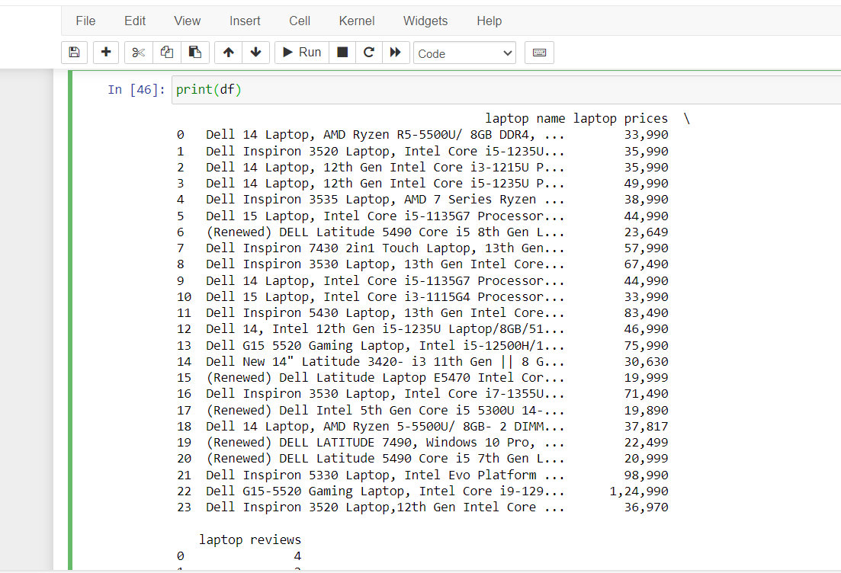

Step-12

df.to_csv("Dell_data.csv")

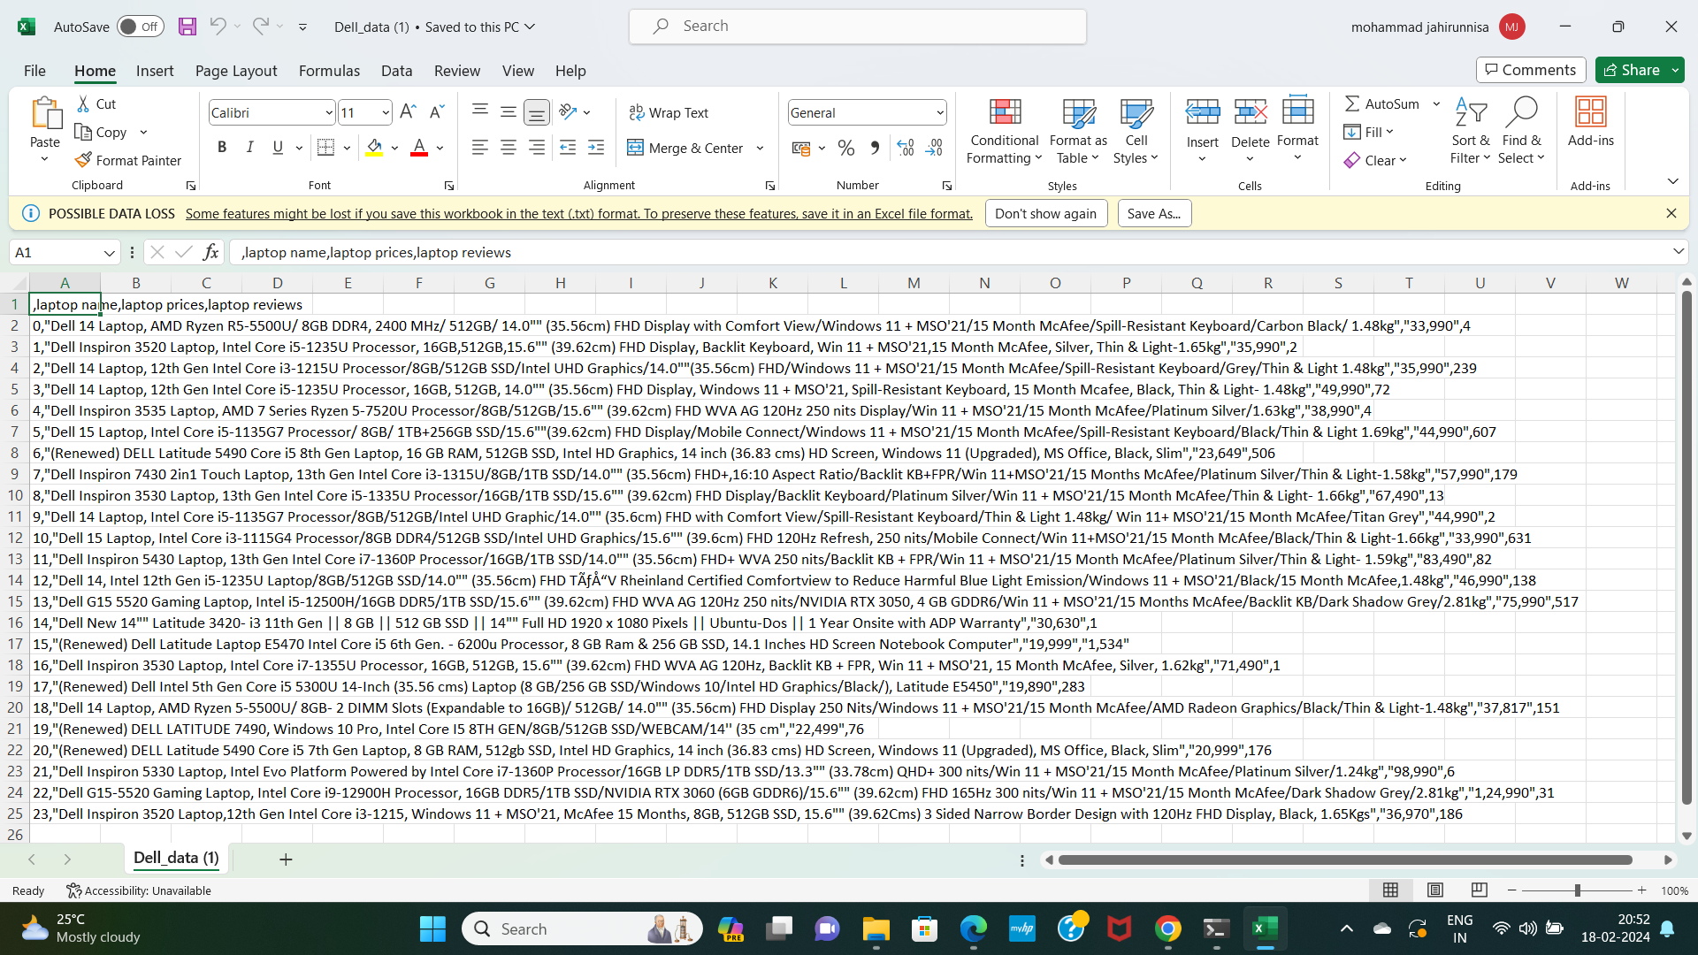

**API -> Application Program Interference**

It is a collection of apps,API of each required app is combined together to form a big app.

It contains the protocols.

a server that you can use to retrieve and send data using code.

>one website fetching the data from one database through direct connection.

>One website fetching the data from different databases belonging to different companies requires

API’s

**Public key:Accessible to everyone.**

**Private key:Accessible to subscribers.**

**>API:**

**connect apps together.**

Eg:Ola

.APP1:Log in --

.APP2:Location --

.APP3:Payment --

.And so on....

>All these small apps are connected together into a large app called Ola.

>These small apps are called APIs and they are building blocks of so many Bigger apps,hence

reusable.

>So if 1f 1000+ apps use these APIs,what happens!

>API crashes...

>Hence API keys are created

**Ex:**

**Random Fox API**

Step-1

import requests

Step-2

page=requests.get('https://randomfox.ca/floof')

Step-3

print(page.status_code)

200

Step-4

print(page.text)

{"image":"https:\/\/randomfox.ca\/images\/1.jpg","link":"https:\/\/randomfox.ca\/?i=1"}

Step-5

print(page.json())

{'image': '<https://randomfox.ca/images/1.jpg>', 'link': '<https://randomfox.ca/?i=1>'}



#This example uses Python 2.7 and the python-request library.

from requests import Request, Session

from requests.exceptions import ConnectionError, Timeout, TooManyRedirects

import json

url = 'https://sandbox-api.coinmarketcap.com/v1/cryptocurrency/listings/latest'

parameters = {

'start':'1',

'limit':'5000',

'convert':'USD'

}

headers = {

'Accepts': 'application/json',

'X-CMC_PRO_API_KEY': 'e8367370-4bd6-483d-8266-0fd11a3a79d5',

}

session = Session()

session.headers.update(headers)

try:

response = session.get(url, params=parameters)

data = json.loads(response.text)

print(data)

except (ConnectionError, Timeout, TooManyRedirects) as e:

print(e)

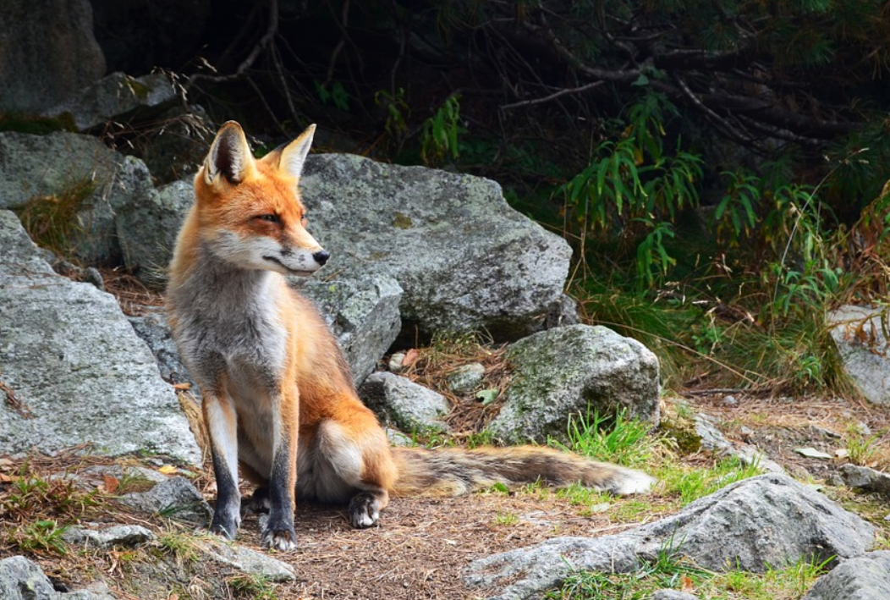

**PROJECT:**

**Extracting data from coinmarketcap API**

Program flow:

1.Go to Coinmarket cap website.

2.Go to Products -->API and obtain API key

3.Go to documentation to obtain API code!

4.Know your code!

5.Run it in any python environment

6.Obtain data in the form of json

7.Normalize the data into a dataframe

8.save it if you needed

Step-1

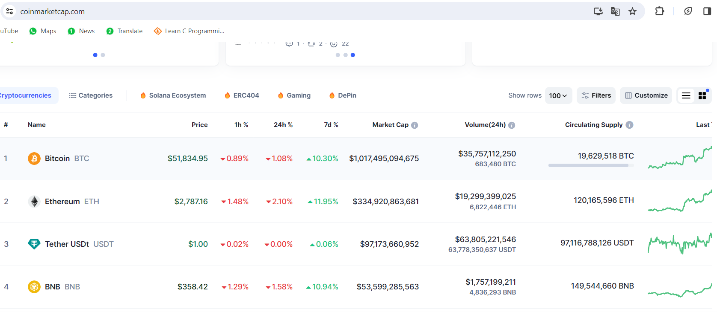

Step-2

API key → c3b7dd81-b6d3-4ef8-a269-a036313f0a41

Step-3

This example uses Python 2.7 and the python-request library.

from requests import Request, Session

from requests.exceptions import ConnectionError, Timeout, TooManyRedirects

import json

url = 'https://sandbox-api.coinmarketcap.com/v1/cryptocurrency/listings/latest'

parameters = {

'start':'1',

'limit':'5000',

'convert':'USD'

}

headers = {

'Accepts': 'application/json',

'X-CMC_PRO_API_KEY': 'e8367370-4bd6-483d-8266-0fd11a3a79d5',

}

session = Session()

session.headers.update(headers)

try:

response = session.get(url, params=parameters)

data = json.loads(response.text)

print(data)

except (ConnectionError, Timeout, TooManyRedirects) as e:

print(e)

**'data': [{'id': 4367, 'name': 'up8ropnbxv', 'symbol': 'g219vxa5yqi', 'slug': 'wf5bij2xf5', 'cmc_rank': 3192, 'num_market_pairs': 4272, 'circulating_supply': 2850**

Step-5

import pandas as pd

norm=pd.json_normalize(data['data'])

norm

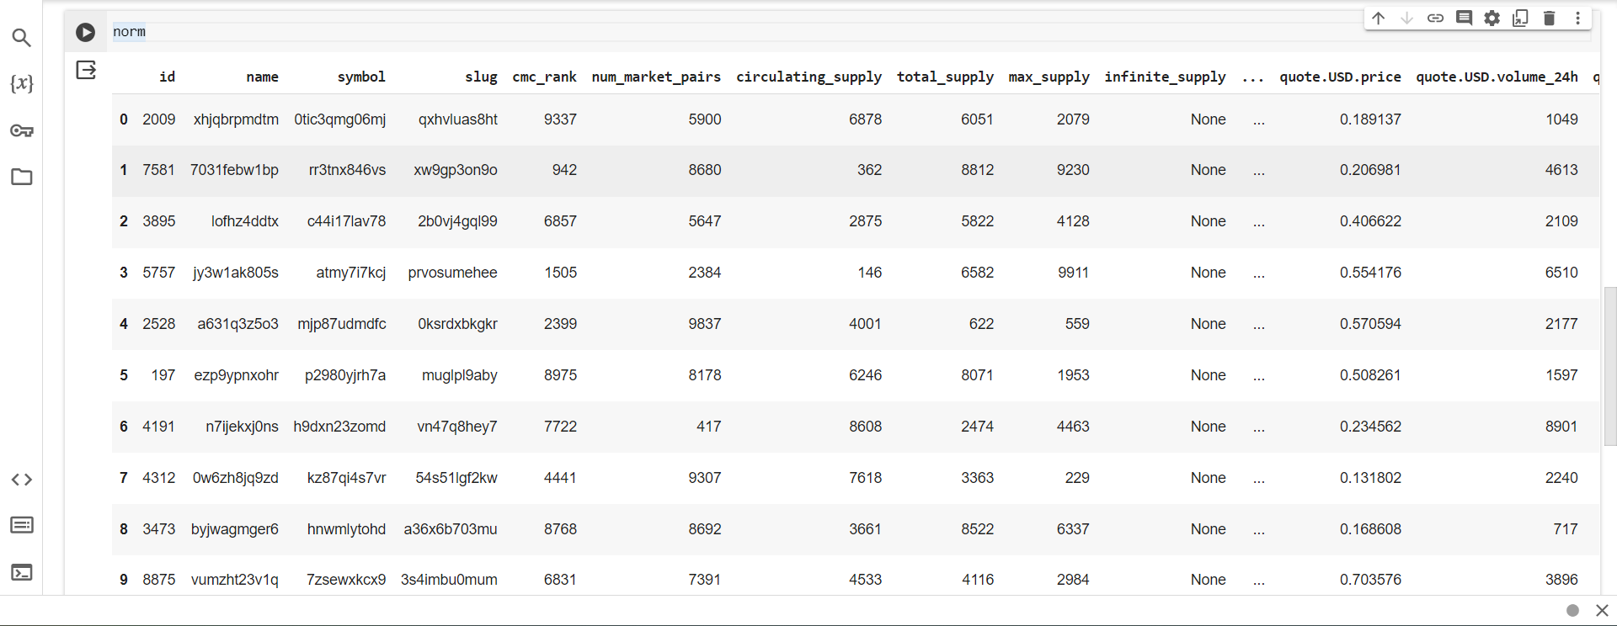

**Machine learning:**

* Like humans learn from their past experiences,machines learn from past data.
* Training a machine on various things is called machine learning.

**Case study:**

A machine will suggest the songs by liked songs the high ratted song will be played to the listener

Types of Machine Learning:

* Supervised
* Unsupervised
* Reinforcement

**Linear regression:**

● It is also a type of machine learning -algorithm.

● Supervised machine learning algorithm.

● Learns from the labelled datasets and maps the data points to the most optimised linear functions.

●These points can be used for prediction on new datasets.

**Dependent and Independent Variable:**

●Independent:

The independent Variable is the cause.Its value is independent of other variables in your study

●Dependent:

The dependent variable is the effect .Its value depends on changes in the independent variable.

**Case Study:**

Consider measurements of a chemical reaction.

The mass of the product increases with time.

The observations are:

| Time(m) | 5 | 7 | 12 | 16 | 20 |
| --- | --- | --- | --- | --- | --- |
| Mass(gms) | 40 | 120 | 180 | 210 | 240 |

Time-Independent

Mass-Dependent

Find the mean of dependent and independent Variable

Regression line is y=a+bx

Regression Calculations:

**Code:**

from sklearn.linear_model import LinearRegression

LR=LinearRegression()#SAVING MODEL COPY

t=[[5],[7],[12],[16],[20]]#time independent 2D array

m=[40,120,180,210,240]#mass dependent

LR.fit(t,m)

**Output:**

LinearRegression

LinearRegression()

**Code:**

LR.predict([[5.5]])#prediction by 2D array

**Output:**

array([78.64935065])

**Logistic Regression**

● It is used for binary classification.

● Supervised learning Algorithm.

**Binary Classification**

Example Segregating Food:

Y=0, Class A-Healthy food

Y=1, Class B -Unhealthy food

**Case Study:**

● Let us take data from Football match.

● Based on the distance between the player and the goal post,we are going to predict whether it is a goal or not.!

● Let us plot some trails now.

● When distance =2m,goal is scored,Y=1

● When distance =4m,goal is scored ,Y=1

● For 5,7,10,20,22m,it is always a goal, Y=1

● When distance=23m,for 15 trails

few are goals Y=1, few are failures Y=0

**Sigmoid Function:**

● Sigmoid function is a s-shaped function with peak at 1 and 0 at valley.

● When model is very confident, Narrow decision boarder

● When model is not confident ,Wide decision border

After plotting the distance vs goal between 20 and 30 metres the probability of goal gradually reduce from 1 to 0

But Logistic Regression accepts only two classes.

So a threshold variable(0.5) is set.

**Prediction is:**

● P>0.5 , It's a goal! -Class A(Y=1)

● P=< 0.5 , It's a Miss! -Class B(Y=0)

**Code:**

import numpy as np

from sklearn.linear_model import LogisticRegression

# Distance and corresponding probability data

distances = np.array([1,2,5,10,15,20, 21, 22, 23, 24, 25, 26, 27, 28, 29, 30,35,40,41,47,50]).reshape(-1, 1)

probabilities = np.array([1,1,1,1,1,1,0.9, 0.85, 0.73, 0.67, 0.5, 0.47, 0.39, 0.31, 0.25, 0.15,0,0,0,0,0])

#convert probabilities to binary labels

threshold=0.5

binary_labels=(probabilities >threshold).astype(int)

#create and fit logistic regression model

logr=LogisticRegression()

logr.fit(distances,binary_labels)

**Output:**

LogisticRegression

LogisticRegression()

**Code:**

logr.predict([[10]])

**Output:**

array([1])

**Code:**

N=logr.predict([[10]])

print(N)

**Output:**

[1]

**Code:**

if p==[1]:

print("Goal")

else:

print("Not Goal")

**Output:**

Goal

**Code:**

#predict 100 distances between 1-50

#Generate distances for prediction

dist = np.linspace(1,50,100).reshape(-1,1)

print(dist)#distances

#make predictions using model

prob = logr.predict_proba(dist)[:, 1]#predictions

print(prob)

**Output:**

[ 1. ]

[ 1.49494949]

[ 1.98989899]

[ 2.48484848]

[ 2.97979798]

[ 3.47474747]

[ 3.96969697]

[ 4.46464646]

[ 4.95959596]

[ 5.45454545]

[ 5.94949495]

[ 6.44444444]

[ 6.93939394]

[ 7.43434343]

[ 7.92929293]

[ 8.42424242]

[ 8.91919192]

[ 9.41414141]

[ 9.90909091]

[10.4040404 ]

[10.8989899 ]

[11.39393939]

[11.88888889]

[12.38383838]

[12.87878788]

[13.37373737]

[13.86868687]

[14.36363636]

[14.85858586]

[15.35353535]

[15.84848485]

[16.34343434]

[16.83838384]

[17.33333333]

[17.82828283]

[18.32323232]

[18.81818182]

[19.31313131]

[19.80808081]

[20.3030303 ]

[20.7979798 ]

[21.29292929]

[21.78787879]

[22.28282828]

[22.77777778]

[23.27272727]

[23.76767677]

[24.26262626]

[24.75757576]

[25.25252525]

[25.74747475]

[26.24242424]

[26.73737374]

[27.23232323]

[27.72727273]

[28.22222222]

[28.71717172]

[29.21212121]

[29.70707071]

[30.2020202 ]

[30.6969697 ]

[31.19191919]

[31.68686869]

[32.18181818]

[32.67676768]

[33.17171717]

[33.66666667]

[34.16161616]

[34.65656566]

[35.15151515]

[35.64646465]

[36.14141414]

[36.63636364]

[37.13131313]

[37.62626263]

[38.12121212]

[38.61616162]

[39.11111111]

[39.60606061]

[40.1010101 ]

[40.5959596 ]

[41.09090909]

[41.58585859]

[42.08080808]

[42.57575758]

[43.07070707]

[43.56565657]

[44.06060606]

[44.55555556]

[45.05050505]

[45.54545455]

[46.04040404]

[46.53535354]

[47.03030303]

[47.52525253]

[48.02020202]

[48.51515152]

[49.01010101]

[49.50505051]

[50. ]]

[1.00000000e+00 1.00000000e+00 1.00000000e+00 1.00000000e+00

1.00000000e+00 1.00000000e+00 1.00000000e+00 1.00000000e+00

1.00000000e+00 1.00000000e+00 1.00000000e+00 1.00000000e+00

9.99999999e-01 9.99999998e-01 9.99999997e-01 9.99999995e-01

9.99999991e-01 9.99999984e-01 9.99999971e-01 9.99999947e-01

9.99999905e-01 9.99999829e-01 9.99999691e-01 9.99999444e-01

9.99998999e-01 9.99998197e-01 9.99996752e-01 9.99994151e-01

9.99989464e-01 9.99981024e-01 9.99965821e-01 9.99938440e-01

9.99889126e-01 9.99800316e-01 9.99640393e-01 9.99352476e-01

9.98834306e-01 9.97902352e-01 9.96228129e-01 9.93226705e-01

9.87866023e-01 9.78355119e-01 9.61678531e-01 9.33032722e-01

8.85522784e-01 8.11129877e-01 7.04524003e-01 5.69669049e-01

4.23619405e-01 2.89797741e-01 1.84703449e-01 1.11725670e-01

6.52734947e-02 3.73232326e-02 2.10715348e-02 1.18095223e-02

6.59122462e-03 3.67018284e-03 2.04100338e-03 1.13418691e-03

6.30014050e-04 3.49879429e-04 1.94281951e-04 1.07873915e-04

5.98940572e-05 3.32538365e-05 1.84626754e-05 1.02504906e-05

5.69105898e-06 3.15966209e-06 1.75423472e-06 9.73945141e-07

5.40730836e-07 3.00211755e-07 1.66676436e-07 9.25381239e-08

5.13768131e-08 2.85242100e-08 1.58365320e-08 8.79238183e-09

4.88149664e-09 2.71018819e-09 1.50468608e-09 8.35395932e-10

4.63808613e-10 2.57504761e-10 1.42965654e-10 7.93739822e-11

4.40681301e-11 2.44664566e-11 1.35836827e-11 7.54160848e-12

4.18707206e-12 2.32464633e-12 1.29063471e-12 7.16555436e-13

3.97828826e-13 2.20873036e-13 1.22627861e-13 6.80825177e-14]

import matplotlib.pyplot as plt

#plotting actual data

plt.scatter(distance,binary_labels,color='black',label='Data')

#plotting test data with predictions - valid/test

plt.plot(dist, prob, color='blue', label='Logistic regression')

plt.title('Distance vs probability of scoring a goal')

plt.xlabel('distance')

plt.ylabel('probability')

plt.legend()

plt.grid(True)

plt.show()

**Output:**

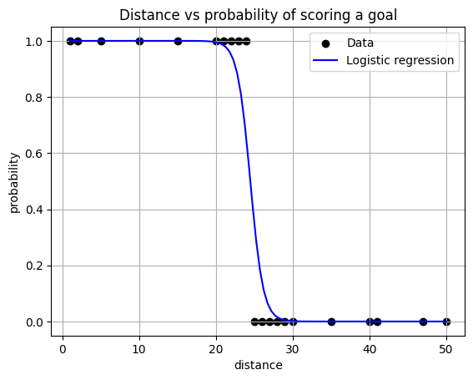

**Decision trees:**

Decision trees in machine learning provide an effective method for making decisions because the lay out the problem and all the possible outcomes

* Have Nodes and Leaves
* Node:Condition having True and False Branches.
* Leaf:Result - showing the dataset that is true and false to the condition

**Case Study:**

* Taking a dataset of 26 states with features like literacy,Cleanliness, Crime Rate and targeting (predicting) Good or Bad state!
* Good is called Target variable here,it has values of 0s and 1s.

**Code:**

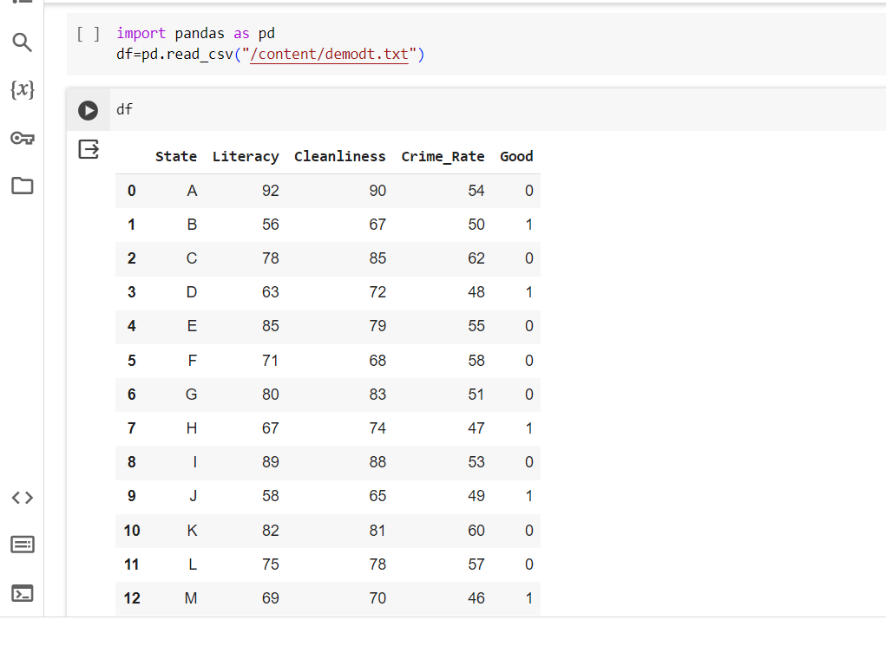

Now let us create a Decision Tree

● Decision tree recurrently (continuously)splits the data until it gets pure leaves

● Let us view a DT based on crime Rate

**Building Decision tree:**

* Node 1:CR>60

True=[C,Q,X=0](pure leaf)

False=[A,E,F,G,I,K,L,N,P,R,U,V=0],[B,D,H,J,M,O,S,T,W,Y,Z=1](its a mix of 0s and 1s)

Reason: the mixed leaf have target variable as both 0s and 1s.hence this data is splitted once again.

* Node 2:CR>50

True=[A,E,F,G,I,K,L,N,P,R,U,V=0](Its a pure leaf)

False=[B,D,H,J,M,O,S,T,W,Y,Z=1](Its a pue leaf)

RESULT:

| **Node** | **Good** |
| --- | --- |
| **CR>60** | **0** |
| **CR<60** | **Cannot be determined** |
| **CR<50** | **1** |

**Predict :**

● Crime rate=63,good=0

● Crime rate =45 good =1

**Random Forest:**

* Collection of decision tree
* Keywords:bootstrapping,aggregation

**Case Study:**

* y- target
* X0,x1,x2,x3,x4- features

**Bootstrapping:**

* Splitting the main dataset into childset

**Conditions:**

* Having same number of rows
* Should have different row combination

**Convolutional Neural Networking:**

● A convolutional NeuralNetwork (CNN) is a type of Deep Learning neural network architecture commonly used in Computer Vision

● It consists of Three layers

**1. Input Layers:**

It's the layer in which we give input to our model.In CNN generally the input will be a image this layer holds the raw data

**2. Hidden layers:**

**→Convolutional Layer:**

● This is the layer ,which is used to extract features from the input dataset .It applies a set of learnable filters known as the kernel to input images.The filters/kernel are smaller matrices usually 2x2, 3x3and 5x5 shape, it slides over the input image data and compute the dot product between kernel weight and the corresponding input image patch.

● The output of this layer is referred to as featured maps.Suppose we use a total of 12 filters for this layer we will get an output volume of dimensions 32x32x12.

**→Activation Layer :**

● By adding an activation function to the output of the preceding layer,activation layers add non linearly to the network.It i will apply an element -wise activation function to the output to the convolutional

● The volume remains unchanged hence output volume will have dimensions 32*332*12.

**→Pooling Layer:**

● This layer is periodically inserted in the converts and its main function is to reduce the size of volume which makes the computation fast reduces memory and also

● If we use a max pool with 2x2 filters and stride 2,the resultant volume will be of dimension 16x16x12.

**3. Output layer:**

The output from the fully connected layers is then fed into a logistic .

classification tasks like sigmoid or softmax which converts the output

**Activation Function:**

❖ The activation function decides whether a neuron should be activated or not by calculating the weighted sum and further adding bias to it.The purpose of the activation function is to introduce non linearity into the output of a neuron.

❖ We know the neural network has neurons that work in correspondence with weight bias and their respective activation function. In a neural network we would update the weights and biases of the neurons on the bias of the error at the output. This process is known as back propagation. Activation functions make the back propagation possible since the gradients are supplied along with the error to update the weights and biases.

**● Tanh :**

=>Tanh Function

1. Value Range-1 to 0.

**●Sigmoid :**

=>Sigmoid Function

1. It's a function which is plotted as a ‘s’ shaped graph.

2.**Equation** A=1/(1+ex)

3.**Nature:** Non-linear that X values lie between -2 to 2, Y values are very steep. This means small changes in x would also bring about large changes in the value Y.

4.Value Range: 0 to 1.

**●Relu :**

1.It stands for Rectified linear unit.It is the most widely used activation function.Chiefly implemented in hidden layers of Neural network.

2**.Equation:-**A(x)=max(0,x).It gives an output x if x is positive and 0 otherwise.

3.**Value range:**-[0,inf)

4**.Nature:**-Nonlinear which means we can easily backpropagate the errors and have multiple layers of neurons being activated by the Relu function.

5.**Uses**:-Relu is less computationally expensive than tanh and sigmoid because it involves simpler mathematical operations.At a time only a few neurons are activated making the network sparse making it efficient and easy for computation.

6.In other words,RELU learns much faster than sigmoid and Tanh functions.

**●Softmax :**

1.The softmax function is also a type of sigmoid function but id handy where we are trying to handle multi class classification problems.

2.**Nature:** non-linear

3.**Uses:**- The softmax function was commonly found in the output layer of the image classification problems.the softmax function would squeeze the outputs for each class between 0 and 1 and would also dividenby the sum of the outputs.

4**.Output:**

The softmax function is ideally used in the output layer of the classifier where we are actually trying to attain the probabilities to define the class of each input.

If your output is for binary classification then,sigmoid function is a very natural choice for the output layer.

If your output is multi-class classification then ,Softmax is very useful to predict the probabilities of each .

**BRAIN TUMOUR:**

**Code:**

import tensorflow as tf

from tensorflow import keras

from tensorflow.keras import layers

from tensorflow.keras.preprocessing.image import ImageDataGenerator

#define image size and batch_size

IMG_SIZE = 224

BATCH_SIZE = 32

from google.colab import drive

drive.mount('/content/drive')

**Output:**

Mounted at /content/drive

#Define data generators for train,validation and test sets

train_datagen=ImageDataGenerator(

rescale=1./255,

validation_split=0.2

)

train_generator=train_datagen.flow_from_directory(

'/content/drive/MyDrive/Brain_Tumor_Detection/train',

target_size=(IMG_SIZE,IMG_SIZE),

batch_size=BATCH_SIZE,

class_mode='binary',

subset='training'

)

val_generator=train_datagen.flow_from_directory(

'/content/drive/MyDrive/Brain_Tumor_Detection/train',

target_size=(IMG_SIZE,IMG_SIZE),

batch_size=BATCH_SIZE,

class_mode='binary',

subset='validation'

)

test_datagen=ImageDataGenerator(rescale=1./255)

test_generator=test_datagen.flow_from_directory('/content/drive/MyDrive/Brain_Tumor_Detection',

target_size=(IMG_SIZE,IMG_SIZE),

batch_size=BATCH_SIZE,

class_mode='binary',

subset='training'

)

**Output:**

Found 1663 images belonging to 2 classes.

Found 415 images belonging to 2 classes.

Found 2138 images belonging to 2 classes

**Code:**

#define the model

model=keras.Sequential([

layers.Conv2D(32,(3,3),activation='relu',input_shape=(IMG_SIZE,IMG_SIZE,3)),

layers.MaxPooling2D((2,2)),

layers.Conv2D(64,(3,3),activation='relu'),

layers.MaxPooling2D((2,2)),

layers.Conv2D(128,(3,3),activation='relu'),

layers.MaxPooling2D((2,2)),

layers.Flatten(),

layers.Dense(128,activation='relu'),

layers.Dense(1,activation='sigmoid')

])

#Compile the model

model.compile(optimizer='adam',loss='binary_crossentropy',metrics=['accuracy'])

history = model.fit(train_generator,validation_data=val_generator,epochs=1)

**Output:**

52/52 [==============================] - 216s 4s/step - loss: 0.4012 - accuracy: 0.8298 - val_loss: 0.2402 - val_accuracy: 0.9301

**Code:**

model.save("Model.h5","label.txt")

**Output:**

/usr/local/lib/python3.10/dist-packages/keras/src/engine/training.py:3103: UserWarning: You are saving your model as an HDF5 file via `model.save()`. This file format is considered legacy. We recommend using instead the native Keras format, e.g. `model.save('my_model.keras')`.

saving_api.save_model(

**Code:**

from tensorflow.keras.models import load_model

from tensorflow.keras.preprocessing import image

import numpy as np

#load the saved model

model=load_model('/content/Model.h5')

#load and preprocess the test image

test_image_path='/content/drive/MyDrive/Brain_Tumor_Detection/test/pred26.jpg'

img=image.load_img(test_image_path,target_size=(224,224))

img_array=image.img_to_array(img)

img_array=np.expand_dims(img_array ,axis=0) #batch dimension

img_array /=255. #normalise the pixel values

#make predictions

prediction=model.predict(img_array)

#print the prediction

if prediction < 0.5:

print("prediction: No tumor (Probability:",prediction[0][0],")")

else:

print("prediction: tumor present (Probability:",prediction[0][0],")")

**Output:**

1/1 [==============================] - 0s 242ms/step

prediction: No tumor (Probability: 0.4817627 )

Statistical analysis using SciPy and statsmodels for hypothesis testing,regression analysis,and ANOVA

**Scipy:**

SciPy is an open-source scientific computing library for Python that builds on NumPy.It provides many additional functionalities compared to NumPy ,including optimization ,integration,,interpolation,eigenvalue problems,signal and image processing,statistical distributions,and much more.

**Code:**

pip install scipy

**Output:**

Requirement already satisfied: scipy in /usr/local/lib/python3.10/dist-packages (1.11.4)

Requirement already satisfied: numpy<1.28.0,>=1.21.6 in /usr/local/lib/python3.10/dist-packages (from scipy) (1.25.2)

**Code:**

import scipy

#Example: Integration using quad function

from scipy import integrate

result, error = integrate.quad(lambda x: x**2, 0, 1)

print("result:", result)

print("error:", error)

**Output:**

result: 0.33333333333333337

error: 3.700743415417189e-15

**Code:**

import numpy as np

from scipy import optimize

#optimization

result_optimization = optimize.minimize_scalar(lambda x: x**2 + 3*x + 5)#-b/2a

print("optimization Result:", result_optimization.x)

**Output:**

optimization Result: -1.5000000000000002

**Code:**

square = lambda x: x**2

#using the lambda function

result = square(5)

print("Result:", result)

**Output:**

Result: 25

**Code:**

import numpy as np

from scipy import interpolate

#interpolation

x_data = np.array([0, 1, 2, 3, 4])

y_data = np.array([0, 2, 1, 3, 5])

interp_func = interpolate.interp1d(x_data, y_data, kind='linear')

interp_result = interp_func(2.5)

print("interpolation Result:", interp_result)

**Output:**

interpolation Result: 2.0

Statsmodels is a Python library that provides classes and functions for estimating and testing

Statistical models.It is built on top of Numpy,scipy,and matplotlib,and it integrates with pandas for data handling.Statsmodel includes a wide range of statistical models and tests , making it a powerful tool for statistical analysis and hypothesis testing.

**Code:**

!pip install statsmodels

import numpy as np

import pandas as pd

import scipy.stats as stats

import statsmodels.api as sm

#generator sample data

np.random.seed(0)

data = pd.DataFrame({

'Treatment': np.random.choice(['A', 'B', 'C'],size=100),

'Score':np.random.normal(loc=10, scale=2, size=100)#loc=>mean,scale=>standard deviation

})

print(data)

**Output:**

Treatment Score

0 A 8.626821

1 B 10.029747

2 A 9.248668

3 B 9.923553

4 B 10.735949

.. ... ...

95 A 9.933528

96 C 10.131283

97 A 10.531571

98 B 12.303684

99 C 10.276086

[100 rows x 2 columns]

**Code:**

#claculate mean score for each treatment group

mean_score_per_group = data.groupby('Treatment')['Score'].mean()

print(mean_score_per_group)

**Output:**

Treatment

A 9.611241

B 10.099304

C 10.010667

Name: Score, dtype: float64

**Code:**

#generate random treatment selections

choices = ['A', 'B', 'C']

size = 100

treatment_column = np.random.choice(choices, size=size)

print(treatment_column)

**Output:**

['B' 'B' 'C' 'A' 'B' 'A' 'B' 'B' 'C' 'A' 'C' 'A' 'C' 'A' 'C' 'A' 'A' 'A'

'A' 'B' 'C' 'A' 'A' 'B' 'C' 'B' 'A' 'A' 'A' 'A' 'A' 'B' 'A' 'C' 'C' 'C'

'A' 'A' 'C' 'A' 'C' 'C' 'A' 'B' 'B' 'B' 'A' 'A' 'B' 'A' 'A' 'B' 'C' 'C'

'A' 'C' 'B' 'B' 'C' 'B' 'C' 'C' 'B' 'C' 'A' 'A' 'C' 'B' 'B' 'C' 'C' 'B'

'A' 'C' 'A' 'C' 'A' 'C' 'B' 'C' 'B' 'A' 'B' 'B' 'C' 'C' 'A' 'B' 'A' 'A'

'A' 'C' 'A' 'B' 'A' 'C' 'B' 'A' 'B' 'C']

**Code:**

#generate random numbers following a normal distribution

mean = 10

std = 2

size = 100

score_values = mean + std * np.random.randn(size)

print(score_values)

**Output:**

[11.04397546 12.39451973 9.23502757 11.38332384 10.70777002 12.09517067

9.15220753 2.97046376 7.31368654 12.85101225 10.45716402 9.48467248

10.10074143 7.23957825 9.47665587 9.64124061 8.61445885 12.27565373

9.6616855 8.47217266 9.00385379 9.27421777 10.52792062 8.74071618

9.05548319 6.97327793 12.21524936 10.3524775 8.11929292 11.85918866

7.87441016 8.22718746 13.84269391 9.08043895 7.82193113 11.96823459

7.68158735 9.12692581 12.01848906 11.42677914 8.54388456 11.67903292

12.47804196 6.43039223 8.40762832 7.19891747 9.63129885 7.21761377

10.07251948 8.37118888 11.39474565 6.52514152 10.2317114 10.73130289

9.85215307 9.01296486 16.20306117 11.71750831 7.69044895 11.88366868

9.43572972 8.04869067 10.19637338 11.81097991 12.03748287 9.77020229

13.48607744 9.35624162 11.65914219 9.58536401 12.23599721 12.12849937

12.30265967 8.45508459 7.41273144 11.35405362 10.8481104 9.02864765

9.89660553 11.13411274 12.13566715 10.54319148 11.23860353 9.88274801

12.5131428 10.59349439 10.79717145 7.89365124 8.72104747 9.70294624

6.85083571 9.00862361 9.76485041 10.74624032 9.22794246 7.53881377

6.08345678 8.96407463 11.15959759 7.29253432]

**Code:**

# hypothesis testing (t-test)

group_A = data[data['Treatment'] == 'A']['Score']

group_B = data[data['Treatment'] == 'B']['Score']

t_stat, p_value =stats.ttest_ind(group_A, group_B)

print("t-statistic:", t_stat)

print("p-value:", p_value)

t-statistic: -1.0341676575352792

p-value: 0.3045674995802033

**Hypothesis test(t-test):**

1. To compare the mean value of two groups (group_a,groupo_b)
2. Performing the t-test (stats.ttest_ind)
3. Performs on independent sample t-test(two sample t-test
4. t-state variable stores the t-statistical value which measures the difference between means of the two groups relative to their variation within the groups.
5. P-value variable stores the probability of observing the given result(less or more extreme)under the null hypothesis(no difference between the groups)
6. If the p_value is predefined significant level example 0.05 we reject the null hypothesis there is a statistically significant difference between the means of the two groups.

**ANOVA test statistic(f-statistic) :**

● It is calculated based on the ratio of the between group variability to the within group variability.

● If the f-statistic is large (greater than expected under null hypothesis) it suggests that group means are not equal.

P-value:

● P-value variable stores the probability of observing the given result(less or more extreme)

under the null hypothesis(no difference between the groups)

● If the p-value is predefined significant level example 0.05 we reject the null hypothesis there is a statistically significant difference between the means of the two groups.

**Interpolation :**

● If the p-value is less than the significance level reject the null hypothesis and conclude that there is significant difference between at least one pair of group mean.

● If the p-value is greater than significant level there is no difference.

**Analysis of variance:**

It is a statistical test used to compare the means of two or more groups to determine if there are any statistical differences between them.It on extension of the t-test it is allowing for the comparison of mean value across multiple groups simultaneously.

**Null Hypothesis:**

The mean value of all groups are equal.

**Alternative Hypothesis:**

At Least one group mean is different from others.

**Assumptions:**

1.Independent Observations - Data points within each group are independent of each other.

2.Normality - Each group's data follows a normal distribution .

3.Homogeneity of variances - The variances of the data in each group are equal.

**Regression analysis:**

**step1:**

* Preparing the data treatment variable is converted from categorical to numerical format
* It adds an constant term(intercept to the model allowing for the estimation of the intercept parameter)(sm.add_constant)

**Step2:**

* Creating regression model
* OLS(ordinary least square regression model)(data[‘score’]).it is a dependent variable(response variable)
* It represents a test score x-independent variable(predictor variable,representing a treatment group)

**Step3:**

* Fitting the regression model
* Fitting the regression model to the data estimating the coefficients(slow and intercept)using an OLS method

**OLS Method:**

* It is from the stats model library in python
* We have the two arrays x,y representing dependent and independent variables
* model=sm.OLS(y,x)
* OLS regression the model it will take the OLS class from statmodels.api(y=dependent,x=independent)